**Project Report**

On

**DESIGN OF BIDIRECTIONAL CONVERTER FOR ELECTRIC VEHICLE CHARGING STATION**

*Submitted in partial fulfillment of the requirements of*

*the degree of*

**Bachelor of Technology**

**in**

**Electrical Engineering**

*By*

**Ashutosh Prakash (**180914**)**

**Atul Pandey (**180915**)**

**Siddharth Sharma (**180942**)**



**Department of Electrical Engineering**

**School of Engineering and Technology**

**Central University of Haryana, Mahendergarh – 123031**

**(June, 2022)**

# **DECLARATION**

We hereby declare that the project report entitled “**DESIGN OF BIDIRECTIONAL CONVERTER FOR ELECTRIC VEHICLE CHARGING STATION**” submitted by us in partial fulfillment of the requirements for the award of Bachelor of Technology in the Department of Electrical Engineering, School of Engineering and Technology, Central University of Haryana. The work was carried out by me at the campus of “Central University of Haryana”. The report has not been submitted to any other University or Institute for the award of any degree or diploma.

# 

Ashutosh Prakash (180914)

Atul Pandey (180915)

Siddharth Sharma (180942)

# 

# 

# **ACKNOWLEDGEMENT**

The satisfaction and euphoria that accompany the successful completion of any task would be incomplete without the mentioning of the people whose constant guidance and encouragement made it possible. We take pleasure in presenting before you our project, which is the result of a studied blend of both research and knowledge.

We express our earnest gratitude to our internal guide Dr. Munish Manas Sir, Assistant Professor, Department of Electrical Engineering, Central University of Haryana for his constant support, encouragement and guidance. We are grateful for his cooperation and his valuable suggestions. We would also like to express our sincere thanks to the Head of Department\ Dr. Rajesh Kumar Dubey. His valuable guidance and support helped us a lot in this project.

Finally, we express our gratitude to all other members who are involved either directly or indirectly for the completion of this project.

Ashutosh Prakash (180914)

Atul Pandey (180915)

Siddharth Sharma (180942)

# C E R T I F I C A T E

This is to certify that the project report entitled “Design of bidirectional converter for electric vehicle charging station” is being submitted **by Ashutosh Prakash, Atul Pandey**, and **Siddharth Sharma** with Roll. No. 180914, 180915 and 180942 respectively in partial fulfillment for the award of Bachelor of Technology in the Department of Electrical Engineering, to the School of Engineering and Technology, Central University of Haryana, Mahedergarh.

**Dr. Rajesh Kumar Dubey,**

Head of the Department,

Department of Electrical Engineering,

School of Engineering and Technology,

Central University of Haryana, Mahendergarh

# C E R T I F I C A T E

This is to certify that the project report entitled “**Design of bidirectional converter for electric vehicle charging station**” is being submitted by **Ashutosh Prakash, Atul Pandey and Siddharth Sharma,** with Roll. No. 180914, 180915 and 180942, respectively in partial fulfillment for the award of Bachelor of Technology in the Department of Electrical Engineering, to the School of Engineering and Technology, Central University of Haryana, Mahedergarh.

**Dr. Munish Manas**,

Department of Electrical Engineering,

School of Engineering and Technology,

Central University of Haryana, Mahendergarh

**Contents**

**Chapter No Name of the chapter Page No**

1. Introduction 8-12

1.1 Background 8-9

1.2 Present Work 9-10

1.3 What is V2G 10-11

1.4 What are the benefits for drivers? 11

1.5 What electric vehicles can give charge 11

back to the network

1.6 INTRODUCTION TO EV CHARGING POINT 11-12

2 Electric Vehicle 13-19

2.1 Introduction 13

2.2 Electric Vehicle & its Types 13-14

2.3 Charger Topology 14-17

2.4 Charger Level 18-19

3 System Configuration 20-22

3.1 System Configuration 20

3.2 Bidirectional AC/DC Converter 20-21

3.3 Modeling of Bidirectional DC/DC Converter 22

4 Control Strategy 24-33

4.1 Introduction 24

4.2 PI Controller 24-30

4.3 Transformation of abc to dq frame 30-33

5 Simulation and Results 34-48

5.1 Simulation 34-36

5.2 Results 36-47

6 Conclusion 48

7 References 49-51

**ABSTRACT**

Electric vehicles are one of the most interesting and important field which has come to the light. With present survey it has been noted that electric vehicles are trying to replace the old traditional vehicles. Electric vehicles will open a door of new era with numerous possibilities. These types of vehicles not only reduce the pollution but also help in conserving natural resources. Researchers are also trying to implement hybrid technology in electrical vehicles which will give us better output with better efficiency. But to make the of electrical vehicle possible, there should be a proper set up starting from its construction to charging stations, all needed to be built systematically. The electric vehicles are needed to be charged periodically. So, proper charging stations are needed to be built at regular intervals. This charging points for these electrical vehicles have certain issues which can damage the vehicles and can also reduce the life of vehicle and can also affect the power quality. The main issue which can cause these problems are mainly related to power quality like harmonics, noises, voltage lag, losses etc. among them the most prominent issues are harmonics and noises due to which the life of battery reduces and will cause a huge impact on cost and can cause a huge stress to grid. In this paper we will be devising a way to counter these issues so that the life of battery can be increased considerable and the quality of power can also be increased.

**Chapter 1 Introduction**

1.1 **Background**

*With the advent of time, there is huge change in technology. The upcoming technologies are more versatile and robust. It has the ability to adapt. One of the most essential factor among them is energy [1]. According to a survey the gross energy consumed in the year of 2018-2019 is of around 1181kwh per capita. According to recent survey India has a total of 99.4% of electricity coverage and among them 79.8% is from fossil fuel and the remaining 17.3% is from*

*renewable energy. Being said that there is a lot of stress in the grid while supplying and maintaining a huge supply of energy daily basis. With the passage of time there is enormous change in the automotive industries. Traditionally fuels like petrol and diesel are originally used. But with the change in technologies, the usage of traditional fuels is removed. A new concept of electric vehicles is introduced. With a present survey it has been found that by the year of 2030, Electric vehicles market is projected to reach 26,951,318 units from an probable 3,269,671 unit in 2019 with a compound annual growth rate of 21.1%. The electric vehicles market has evolved rapidly with the constant support of government and customers [2,3]. Electric vehicles have almost penetrated the market and is huge success over the traditional vehicles. Due to several benefits electric vehicles are considered. It is regarded as one of the best methods which can be used in the process of eliminating pollutions. According to the world energy council a percentage of 17% of greenhouse gasses released to the environment comes from the vehicles. So, to control this alarming rate of emission, electric vehicles are suggested to replace the traditional vehicles. Electric vehicles are handier and are more easy to use and are more cheaper mode of transportation. This type of vehicles uses little or no fuel for its functioning, thus reducing the possibility of greenhouse gas emission which mainly consists of carbon dioxide.*

*Traditional energy costs have grown dramatically in recent years as a result of environmental deterioration, climate change, and a scarcity of fossil fuels. As a result, it is critical that new and clean energy be used globally. Electric vehicles (EVs) and plug-in electric vehicles (PEVs) are gaining popularity around the world [4-6], due to the representativeness of new energy vehicles. EVs and PEVs have numerous advantages, including peak power regulation, peak load shifting, environmental protection, low cost, and so on. EVs and PEVs can be both loads and generators in grid-to-vehicle (G2V) charging and vehicle-to-grid (V2G) discharge modes [7] Both V2G and G2V applications are often acceptable for "V2G.".*

*The power converter is unidirectional for G2V in general, which includes conventional and fast charging systems. Owing to the fact that the power of typical electrical vehicles is twice higher than the average household load, the grid network will be stressed by the fast charging [8]. If the G2V charger does not use the most up-to-date conversion, grid disturbances such as undesired peak loads, harmonics, and low power factor may occur [9, 10]. As a result, in a V2G system, it is critical to support energy injection back to the grid. The bidirectional grid-connected AC/DC converter, which can realize sinusoidal input current and bidirectional power flow, is an essential part of the V2G system. The major research directions for bidirectional AC/DC converters for V2G applications are improving power density, reducing input and output current ripple, and having reactive power compensation capability [11-13].*

**1.2 Present Work**

*Various AC/DC converter topologies have been utilized in the V2G system in recent years, including single-stage single-phase and three-phase, two-stage single-phase and three-phase, ZVS inverter, and so on [14, 15]. Reference [16] presents an electrical vehicle charger that uses a single-phase interleaved AC/DC boost converter. In [17], a high-performance single-phase bridgeless interleaved PFC converter is proposed. Both [16, 17] provide the same job of reducing battery charge and discharge current ripple, but none can work with a wide output voltage. Unidirectional buck-boost converters with wide output voltage are proposed in [18, 19], which can lower AC current Total Harmonic Distortion (THD). All of these converters are unable to transfer battery energy back to the grid due to the unidirectional switches. To realize the bidirectional power flow, the AC/DC matrix converters are proposed in [20]. The converter, on the other hand, is noted for its huge number of semiconductor switches and high-frequency operation, which means higher costs and heavier losses, such as switching and conduction losses. In [21], a current-source rectifier is shown with an auxiliary switching network. The study in [22] proposed a current-source rectifier with PWM pulse signal trilogic control method. [23, 24] proposes an intelligence protection technique that can be applied to high-power grid-connected converters. The maximum current control and grid voltage full-feedforward technique for three-phase voltage-source rectifiers was presented by the authors of [25, 26].*

*When utilized in V2G, the topologies discussed above have various drawbacks, including a narrow output voltage range, substantial losses, and high input current ripple. This study analyzes and designs a three-phase bidirectional grid-connected converter for V2G systems, which achieves bidirectional power flow, high efficiency, unity power factor, and a wide battery pack voltage range as an effective alternative.*

**1.3 What is V2G**

The abbreviation V2G hides the vehicle to grid designation. This is a technology that involves the use of a car as a kind of capacity for storing electricity. We are talking, of course, about electric cars.

Numerous studies have shown that the vast majority of personal cars are not used 95% of their time. Based on this, it was assumed that an electric car connected to the network can be charged with a minimum load of the network, and on the contrary, during peak hours, the electric car will be able to give off the electricity stored by its battery.

To implement V2G technology, special bi-directional charges are required, which can regulate the power transmission of energy in both directions (charge/discharge) by measuring the frequency of the current in the network. An external device is used to measure the frequency of the current, which transmits the received information to the charging station using a special connection. In turn, the charging station, having received the information, begins to work in the standard mode of charging the car or turns on the reverse mode, taking the "extra" energy from the electric car

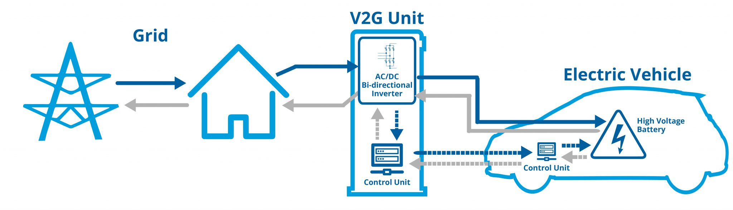

**1.4 What are the benefits for drivers?**

Of course, this raises the question of the value of this technology for a particular electric vehicle owner. What is the benefit or advantage of this technology? The advantage here is that the owner gets the opportunity to charge his car at a lower rate, while the return (or sale) of electricity is carried out at a higher rate.

Specific figures may vary from country to country. For example, in the United States, it has been calculated that in this way the owner of an electric car can earn up to $ 4,000 a year. And Nissan experts have calculated that this technology will make it possible for a car owner to earn up to $ 1,000 a year.

Important! Also, an electric car with a charge return function can act as additional energy storage for a private house. For your information. A family of three consumes about 10 kWh per day. Thus, the same Nissan Leaf, equipped with a 30-kWh battery, can provide a house with electricity for 3 days.

**1.5 What electric vehicles can give charge back to the network**

Almost all major manufacturers are promoting V2G technology (of course, these are Tesla, as well as Fiat Chrysler, Nissan, Honda, Toyota, Mitsubishi, and others). One of the first electric cars that "learned" to give electricity back in 2012 is the almost legendary Nissan Leaf. Further, it is worth mentioning Nissan e-NV200, Nissan Ariya, Renault Zoe (first generation), Honda e. Tesla Model 3 also has two-way charging. Audi plans to implement V2G technology in the near future.

**1.6 INTRODUCTION TO EV CHARGING POINT**

India is a developing country. With the development comes the changes. As electric vehicles are margins in the current market, it has gained widespread popularity. But there is still a problem which is faced by electric vehicle owners. There is no sufficient electric vehicle charging point. Although initiatives are taken by the government to set up electric vehicle charging stations, the maximum charging activities are done privately which might be illegal as they might not have proper permits. This kind of activity puts an enormous amount of stress on the grid. These problems result in degrading the power profile of the grid. Due to this kind of activity the power demand increases which leads to a lot of problems.

As with the passage of time EVs are taking over market, it is having both positive and negative impacts. The impacts are listed below.

**1.6.1. Positive Impacts**

• Reduced greenhouse gas emission.

• Cheaper mode of transportation.

• Reduced utilization of fossil fuels.

• Easy integration with renewable sources of energy.

• Can be integrated with smart grid technology.

**1.6.2. Negative impact**

• Power demand increases.

• Production of harmonics

• Reduction of power factor on transformer.

• Lower power profile.

**CHAPTER 2**

**Literature Survey**

**2.1 INTRODUCTION**

A bidirectional converter technology is going to reduce problems like fuel cost, environmental pollution, and carbon-emission in modern electric vehicles. Advancement in electric vehicle with bidirectional converter opens a wide range to utilize stored

energy in a battery. Continuous improvement in electric vehicle charging infrastructure creates an easy way to transfer energy from vehicle-to-grid or from grid-to-vehicle. There are lots of other important factors including energy transfer from vehicle-to-grid or form grid to vehicle, so in this literature survey we discuss all the factors including designing controlled bidirectional electric vehicle chargers.

**2.2 ELECTRIC VEHICLE & ITS TYPES**

Main concern of moving towards electric vehicles is pollution free environment or less carbon emission. In the case of electric vehicles, we use a battery for power storage. The energy is used to power electric vehicles for making the pollution free instead of internal combustion engines. There are various integrated models which make it more reliable and efficient. There are mainly four electric vehicles until now. Types and comparison between types of electric vehicle is shown in figure 2.2.1

i) Hybrid Electric Vehicle

ii) Plug-in Hybrid Electric Vehicle

iii) Battery Electric Vehicle

iv) Mild Hybrid Electric Vehicle

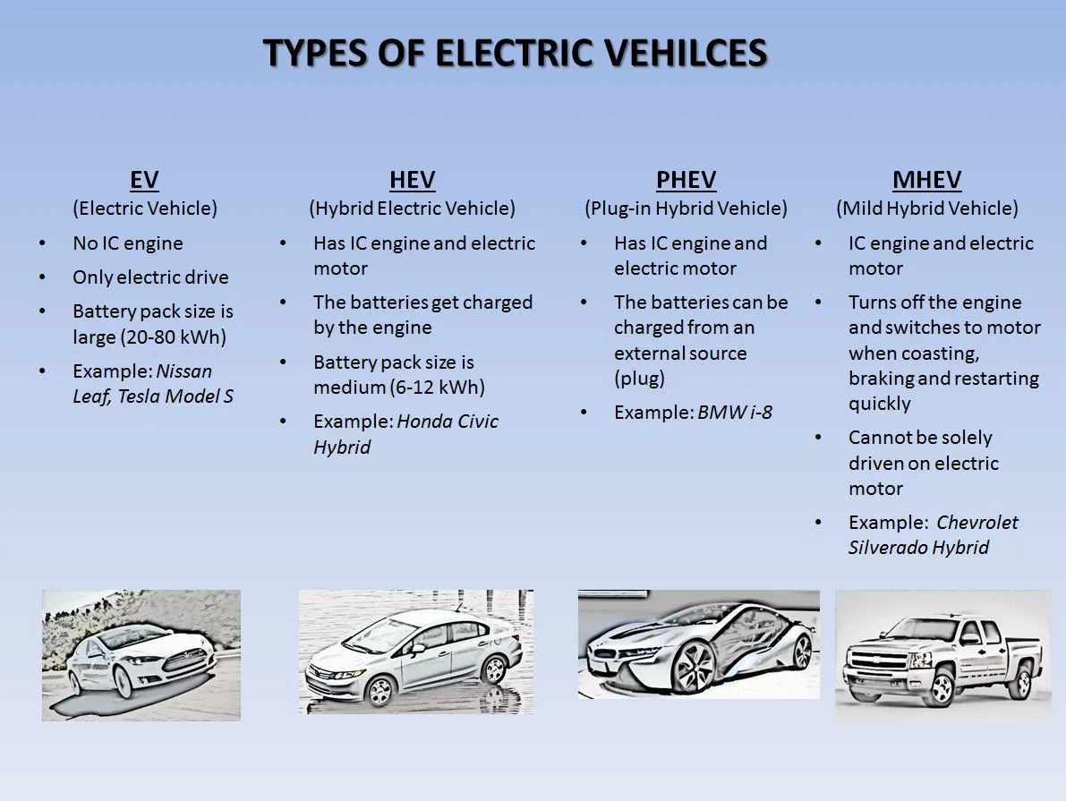

**Fig 2.2.1 [Types of electric vehicle]**

* ***Hybrid Electric Vehicle***

*A hybrid electric vehicle (HEV) [27] is a type of hybrid vehicle that combines a conventional internal combustion engine (ICE) system with an electric propulsion system (hybrid vehicle drivetrain). The presence of the electric powertrain is intended to achieve either better fuel economy than a conventional vehicle or better performance.*

* ***Plug-in Hybrid Electric Vehicle***

*A plug-in hybrid electric vehicle (PHEV)[28] is a hybrid electric vehicle whose battery pack can be recharged by plugging a charging cable into an external electric power source, in addition to internally by its on-board internal combustion engine-powered generator.*

* ***Mild Hybrid Electric Vehicle***

*Mild hybrids (also known as power-assist hybrids, battery-assisted hybrid vehicles or BAHVs)[29] are generally cars with an internal combustion engine equipped with an electric machine (one motor/generator in a parallel hybrid configuration) allowing the engine to be turned off whenever the car is coasting, braking, or stopped, yet restart quickly.*

* ***Electric vehicle***

*A battery electric vehicle (BEV), pure electric vehicle, only-electric vehicle, fully electric vehicle or all-electric vehicle is a type of electric vehicle (EV) that exclusively uses chemical energy stored in rechargeable battery packs, with no secondary source of propulsion (e.g., hydrogen fuel cell, internal combustion engine, etc.). BEVs use electric motors and motor controllers instead of internal combustion engines (ICEs) for propulsion.*

**2.3 CHARGERS TOPOLOGY**

Nowadays due to advancements in electric vehicles it will significantly affect the power grid. Vehicle-to- grid concept transfers the energy from vehicle to grid but it generates the harmonics and power imbalance in the power system. So, to overcome power system instability, manufacturers focus on more advancement in bi-directional chargers to smoothing the waveform of injecting current and active power or reactive power control during transfer energy from vehicle-to-grid or from grid-to-vehicle. To transfer vehicles to the grid it should be properly controlled and regulated. Nowadays fast charging facilities and long duration capability are required in plug-in hybrid electric vehicles which are overcome by advancement in bi-directional chargers at different levels of charging. Electric vehicle chargers can be broadly classified as unidirectional chargers or bi-directional chargers. If classification criteria fixed on electric vehicle manufacturers design, then it classified with on-board and off-board chargers and if we take the direction of power flow then it will be categorized into conductive/ wired and inductive/ wireless chargers

2.3.1) Uni-directional charger and Bi-directional charger

2.3.2) On-board charger and off-board charger

2.3.3) Conductive charges and Inductive charges

**2.3.1 UNIDIRECTIONAL CHARGER AND BI-DIRECTIONAL CHARGER**

* ***Unidirectional Charger***

*Two types of power flow are possible between EVs and the electric grid. EVs with unidirectional chargers can charge but not inject energy into the power grid. These chargers typically use a diode bridge in conjunction with a filter and dc–dc converters. Today, these converters are implemented in a single stage to limit cost, weight, volume, and losses.*

* ***Bidirectional Charger***

*These chargers can use non-isolated or isolated circuit configurations. When operating in charge mode, they should draw a sinusoidal current with a defined phase angle to control power and reactive power. In discharge mode, the charger should return current in a similar sinusoidal form. A bidirectional charger supports charge from the grid, battery energy injection back to the grid, referred to as vehicle-to-grid (V2G) operation mode, and power stabilization.*

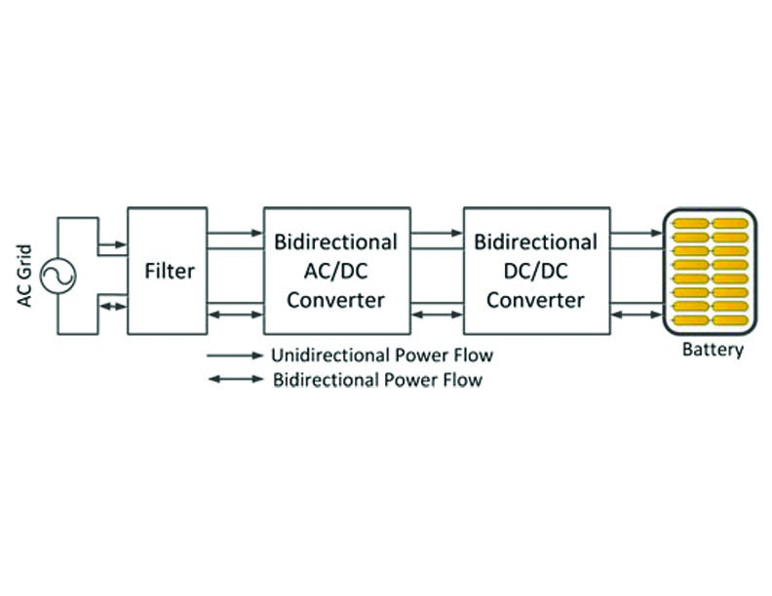

***2.3.2 CONDUCTIVE CHARGER AND INDUCTIVE CHARGER***

* ***Conductive charging system***

*Conductive charging uses direct contact between EV connector and charge inlet. The cable can be fed from a standard electrical outlet or charging station. There are two methods employed in EV charging stations using conductive method viz. AC chargers and DC chargers****.***

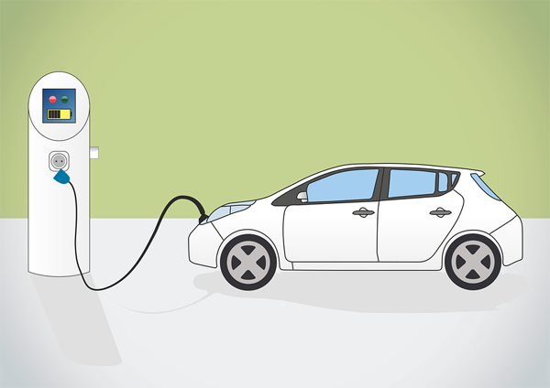

***Fig 2.3.2.1 [ Conductive Charging]***

* ***Inductive charging system***

*Inductive charging uses an electromagnetic (EM) field to transfer energy between two objects. Charging station was developed for this purpose. Energy is transmitted through inductive coupling to electrical devices. This energy is used to charge batteries.*

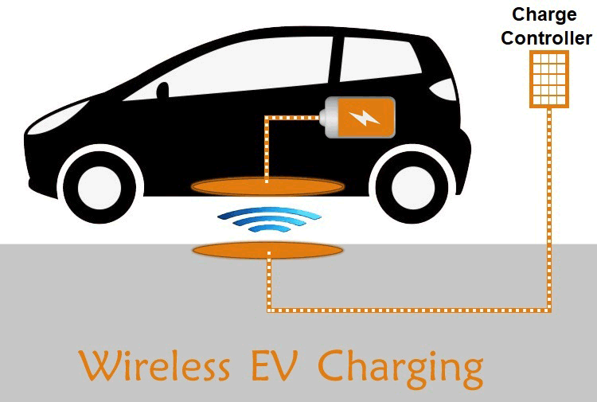

***Fig 2.3.2.2 [Inductive Charging]***

***2.3.3 ON-BOARD CHARGER AND OFF-BOARD CHARGER***

* ***On-Board charging system***

*On board charger consist of a dc-dc converter in electric vehicles to convert the dc*

*output at safe battery charging level. An on-board charger comes in wireless charger*

*and has level 1 and level 2 charging power. Due to weight, space and cost constraints*

*and on-board charger have bidirectional ac-dc Converter in their configuration which*

*converts the grid ac supply to dc for electric vehicle and electric vehicle convert that dc*

*into step up or step-down dc for charging the battery or supply to the grid or home. On*

*board charger can charge from single phase or three phase ac supplies but due to weight*

*and size constraint it is designed only for single phase AC supply*

* ***Off-Board Charging System***

*Off board charges are external and standalone type charges compared to on*

*board charges. Bidirectional ac-dc converters and bidirectional dc-dc converters are in*

*integrated form into off board chargers. They can be either operated in single phase*

*and three phase ac supplies or can be an inductive or conductive type of charger. However*

*it mainly functions for level 3 charging or three phase ac supply, it means the provides*

*three times more power in an electric vehicle. Hence it is suitable for dc fast charging. Off*

*board charger contains power factor correction to manage 3 phase ac input and it rectify*

*into dc voltage. Now dc-dc converter step-up or step-down the dc output at safe battery*

*charging level.*

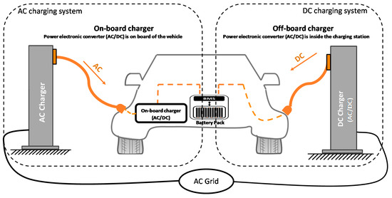

***Fig 2.3.3.1 [on-board & off- board charging]***

***2.4 CHARGER LEVEL***

We’ve been refueling our cars with gasoline for more than a hundred years. There are a few variants to choose from: regular, mid-grade or premium gasoline, or diesel. However, the refueling process is relatively straightforward, everybody understands how it’s done, and it’s completed in about five minutes.

However, with electric vehicles, refueling—the recharging process—isn’t quite as simple, or as quick. There’s a number of reasons why that’s so, such as the fact that every electric vehicle can accept different amounts of power. There are also different types of connectors used, but most importantly, there are different levels of EV charging that determine how long it takes to charge an EV.

Charging levels and charging times apply to EVs and plug-in hybrids, but not to traditional hybrids. Hybrids are charged by regeneration or by the engine, not by an external charger.

***Three levels of EV charging***

1. ***Level 1 Charging:*** *Level 1 charging uses a common 120-volt household outlet. Every electric vehicle or plug-in hybrid can be charged on Level 1 by plugging the charging equipment into a regular wall outlet. Level 1 is the slowest way to charge an EV. It adds between 3 and 5 miles of range per hour.*

*Level 1 charging works well for plug-in hybrid electric vehicles (PHEVs) because they have smaller batteries, currently less than 25 kWh. Since EVs have much larger batteries, Level 1 charging is too slow for most daily charging, unless the vehicle isn’t needed to drive very far on a daily basis. Most BEV owners find that Level 2 charging better suits their daily charging needs.*

1. ***Level 2 charging: [208V-240V]*** *Level 2 charging is the most commonly used level for daily EV charging. Level 2 charging equipment can be installed at home, at the workplace, as well as in public locations like shopping plazas, train stations and other destinations. Level 2 charging can replenish between 12 and 80 miles of range per hour, depending on the power output of the Level 2 charger, and the vehicle’s maximum charge rate.*

*Most BEV owners choose to install Level 2 charging equipment at their residence, because it charges the vehicle up to 10 times faster than Level 1 charging. Charging from a Level 2 source usually means the vehicle will be completely charged overnight, even if you are plugged in with a nearly empty battery.*

1. ***Level 3 charging :*** *[****400V-900V]{DC Fast Charging}*** *Level 3 charging is the fastest type of charging available and can recharge an EV at a rate of 3 to 20 miles of range per minute. Unlike Level 1 and Level 2 charging that uses alternating current (AC), Level 3 charging uses direct current (DC). The voltage is also much higher than Level 1 & 2 charging, which is why you don’t see level 3 chargers installed at home. Very few residential locations have the high-voltage supply that is required for level 3 charging.*

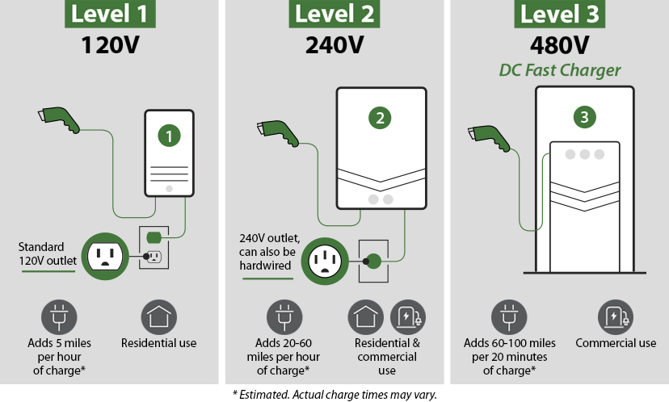

**CHAPTER 3**

**System Configuration**

**3.1. *System Configuration***

*The configuration of the V2G system is shown in Figure; the system consists of three parts, AC grid, converters, and loads. AC grid supplies original AC voltage to converters through a transformer. Converters consist of AC/DC converter and DC/DC converter. The AC/DC converters transform AC energy to DC energy. The bidirectional DC/DC converter connects the battery to the DC bus. In this project, charging the battery is defined as positive; on the contrary, discharging is defined as negative.*

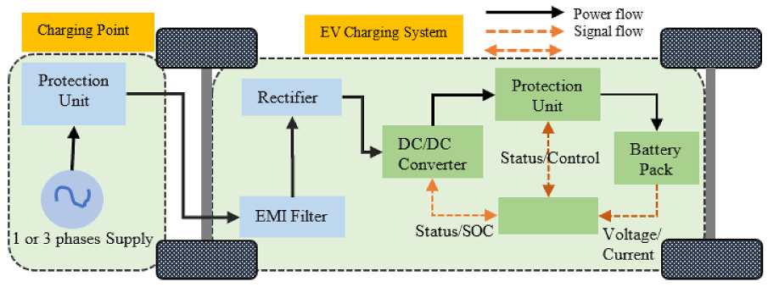

***3.2. Bidirectional AC/DC Converter***

Conventional ac/dc converter works only the rectifier mode but advancement in converter topology opens a new option to flow electric power in both directions to reduce the fuel consumption, and load on grid by sending power grid to vehicle in daytime and also, supply vehicle-to-grid during the peak time. The basic concept of vehicle-to-grid is possible through the integration of a bidirectional ac/dc converter with a bidirectional dc/dc converter. And single-phase bidirectional ac-dc converters topology model to transfer an ac grid voltage by transfer into dc at step up voltage and during vehicle-to-grid energy transfer, works as an inverter mode and step-down ripple free voltage. Figure 3.2.1 shows the configuration of three phase full bridge bidirectional AC-DC converter. There are various charging strategies to charge the electric vehicle. However, both on board and off board charging infrastructure with low level charges required for single phase bidirectional ac/dc charger topology.

The grid integration with bidirectional ac/dc converter as shown in figure 3.1, creates the main issues such as power factor correction, harmonic in voltage/current, ripples in output voltage/current and the efficiency of the system during the transfer from grid-to-vehicle and vehicle-to-grid.

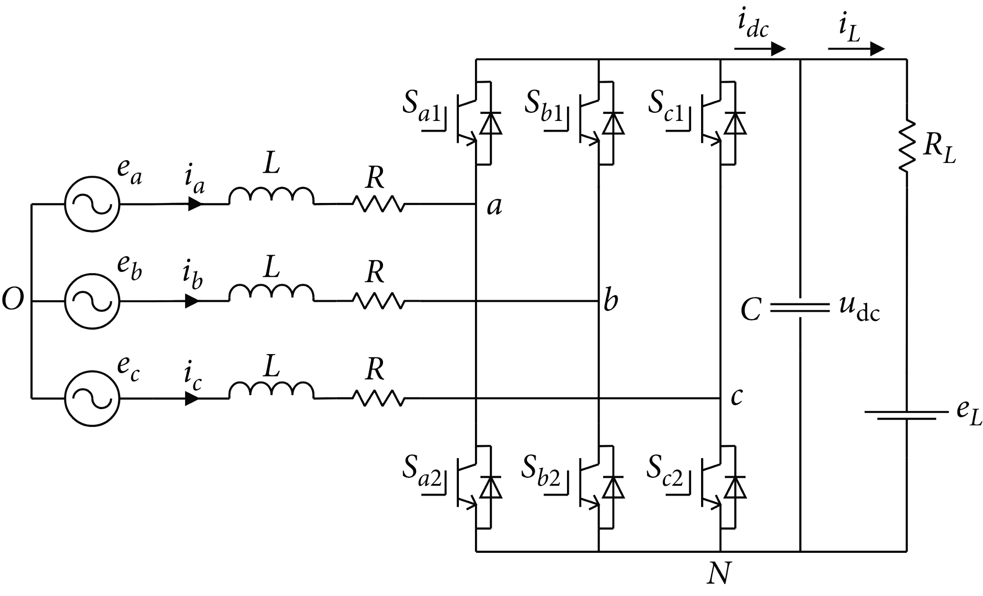

1. Current harmonic fluctuates the grid voltage which also responsible to crash electrical equipment on the grid.

2. Current harmonic with fundamental increases the current magnitude which causes loss in machines and overheats lead hard to operate at actual rating.

3. At low power factor more current draw from load to maintain unity power factor which reduces system efficiency.

4. All electric vehicle manufacturing countries have their standards i.e. Harmonic standards to maintain the power system stability.

According to IEEE, maximum 5% total harmonic distortion allowed in voltage harmonic distortion and for current harmonic, it depends on short-circuit capacity of line at point of common coupling.

***3.3. Modeling of Bidirectional DC/DC Converters***

*The topology of the bidirectional DC/DC converter is shown in Figure, which connects the DC bus to the battery pack. And the bidirectional H-bridge DC/DC converter will meet the wide voltage requirement of the battery. The DC bus voltage of a DC/DC converter is denoted as Vbus.*

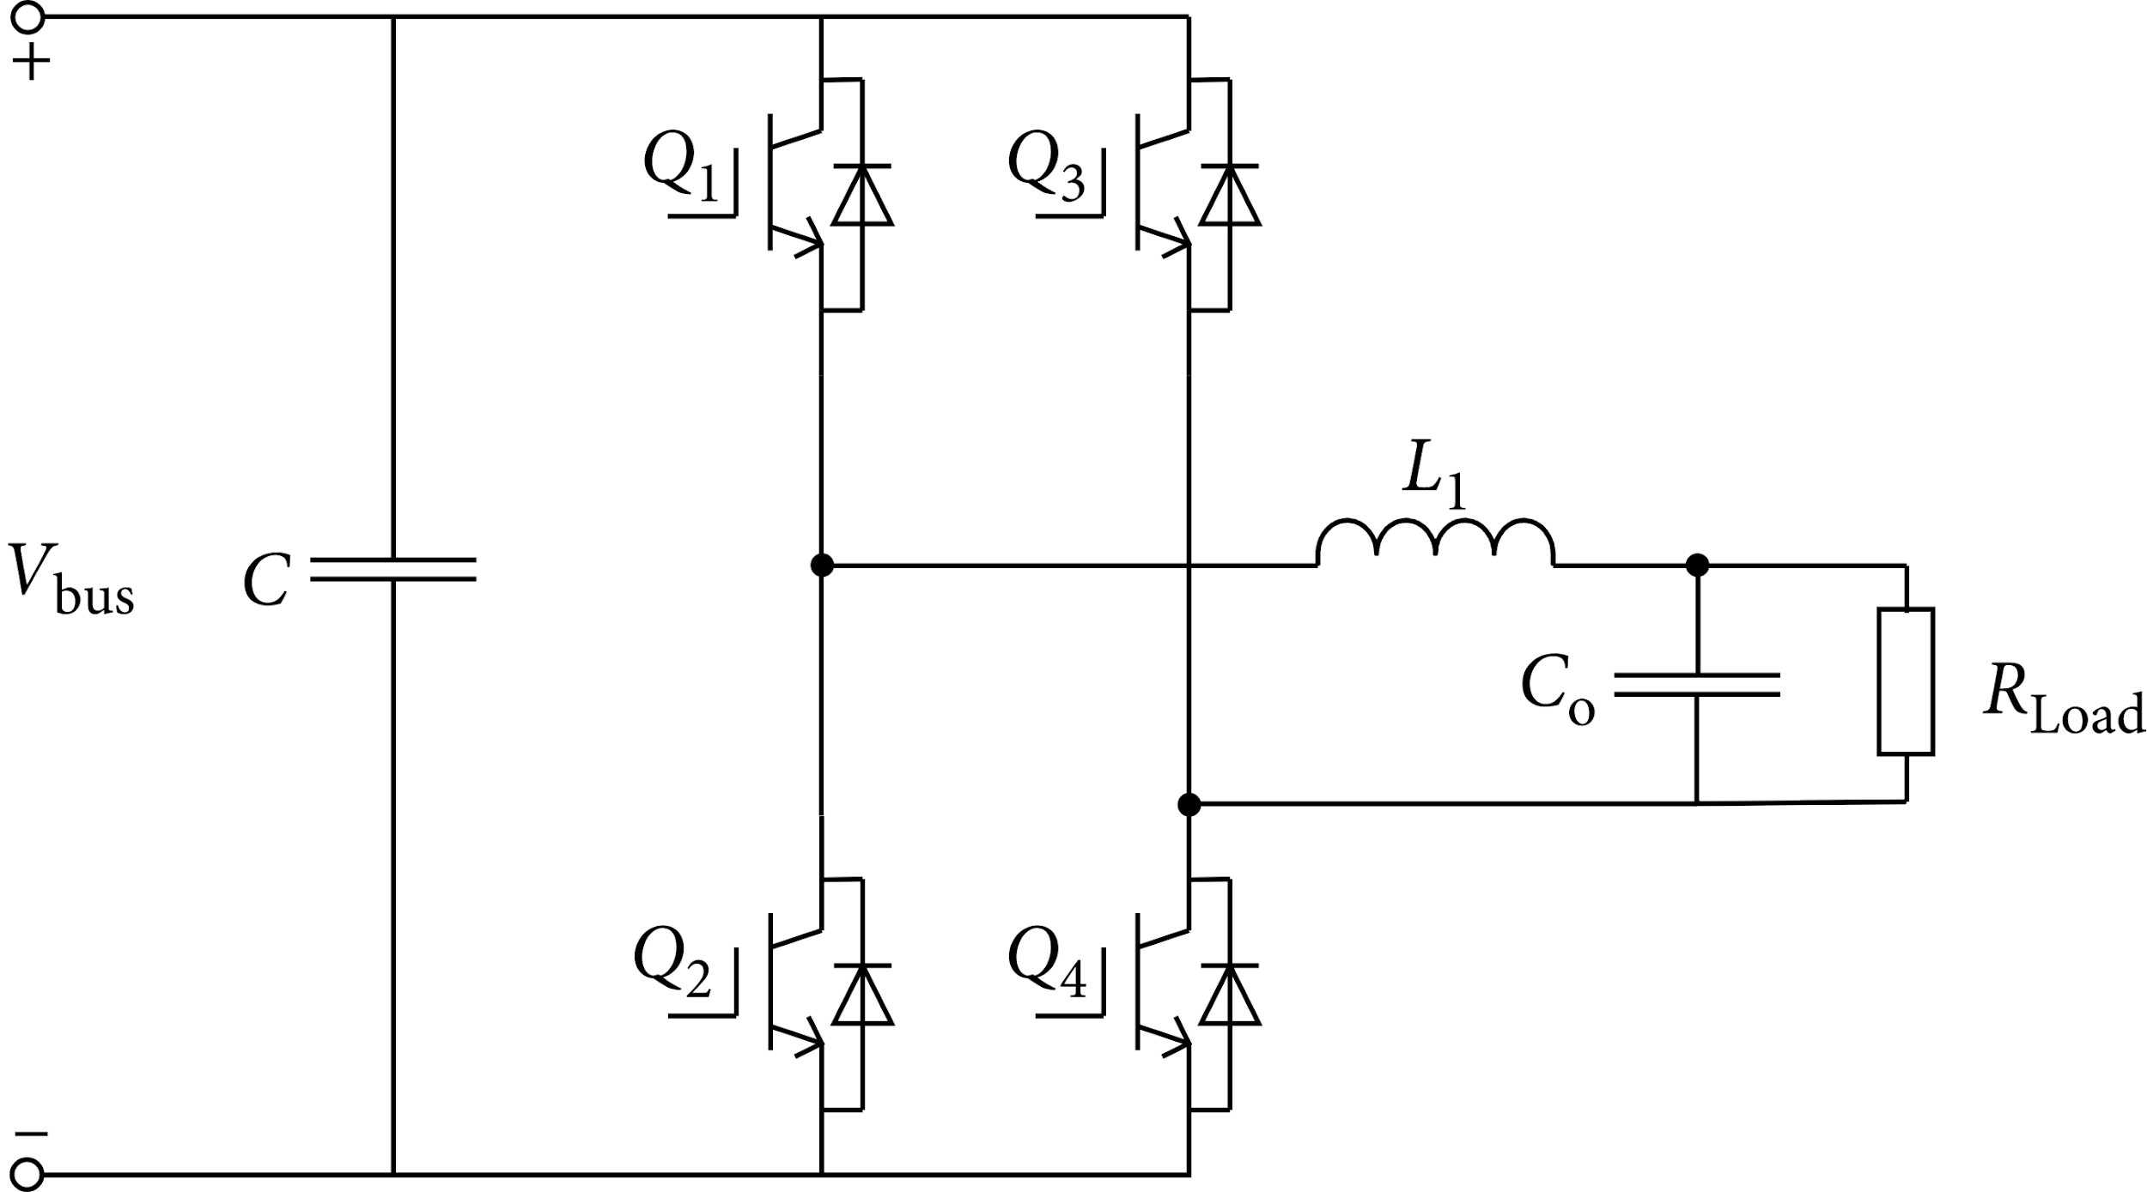

*The converter works in buck mode for charging the battery. On the contrary, the converter works in boost mode for discharging the same.*

***Chapter 4***

***Control Strategy***

***4.1* Introduction**

*The power structure must be controlled separately; it means that there are two different control algorithms, one for the BDC and another one for the BADC. The BDC control is responsible for deciding between the two different modes of operation. If the power must be injected into the grid, the DC-DC converter assumes the V2G mode and acts as a step-up converter. If the battery must be charged, the converter assumes the G2V mode and acts as a step-down converter*

*In this research work we are controlling different parts of the model. First, we are controlling our front-end converter which consists of a bidirectional AC/DC converter and second, we are controlling the bidirectional DC/DC converter with the help of a PI controller. In this we are transforming our grid voltage in dq frame during charging of battery and vice versa during discharging of battery i.e., during v2g.*

*Based on the previously described model of the three-phase bidirectional grid-connected AC/DC converter with L filter, this section has introduced the converter control strategy. The DC bus voltage of the V2G system is the main control object. Therefore, the most widely used control strategy, the voltage outer-loop, and current inner-loop PI control are applied in this project. So as to improve the stability of the system, the grid voltage feedforward decoupling scheme is used.*

***4.2 PI Controller***

*Proportional Integral controller sometimes also known as proportional plus integral (PI) controllers. It is a* [*type of controller*](https://electronicscoach.com/types-of-controllers.html) *[30] formed by combining proportional and integral control action. Thus, it is named as PI controller.*

*In a proportional-integral controller, both proportional and integral controllers are used to govern the system. This combination of two separate controllers results in a more efficient controller that eliminates the drawbacks of each of them individually.*

*The control signal is proportional to the error signal as well as the integral of the error signal in this situation. The proportional plus integral controller is represented mathematically as:*



*The figure below represents the block diagram of the system with PI controller:*

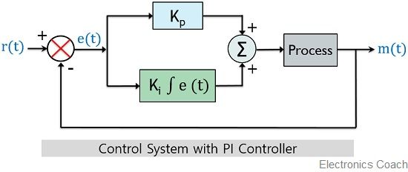

***Fig [block diagram of PI controller]***

*Let us discuss about P and I controller individually*

***4.2.1. Proportional Controller***

*Proportional controllers are referred to as the type of controllers in which the output signal shows proportionality with the error signal. It is given as*

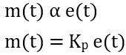

***4.2.2. Integral Controller***

*Integral controllers are the type of controllers where the output is proportional to the integral of the error signal. Thus, is given as*

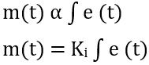

*It is to be noted here that one can use integral controllers separately without combining it with proportional controllers. However, generally proportional plus integral controllers are used that combinely overcome the disadvantage of integral controllers.*

*A major disadvantage which is associated with the integral controller is that these are quite unstable. The reason behind this is that integral controllers show somewhat slow response towards the produced error.*

*However, the major advantage concerning the proportional controller is that these are designed in a way by which steady-state error gets reduced significantly thereby making the system more stable.*

*This is the reason the two are combinedly used to produce a type of controller which provides highly stable results.*

## *Proportional Integral Controller*

*Till now we have discussed what is proportional and integral controller individually. So, let us now understand how the two are combined.*

*So, in this, the control signal is formed by merging error and integral of the error signal.*

*Thus, is given as:*

**

*This can also be written as:*

**

*In order to have the transfer function of the controller, we need to consider the Laplace transform of the above equation, so it is given as*

**

*It is to be noted here that the error signal will act as input that will cause variation in the output of the controller.*

*Thus, on transposing E(s) to the LHS, we will get*

**

*On further simplification, we will get*

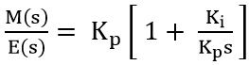

*Thus, it can be written as:*

**

*This equation represents the gain of the PI controller.*

***: Ti = Kp/Ki***

*So, the block diagram of a PI controller is given as:*

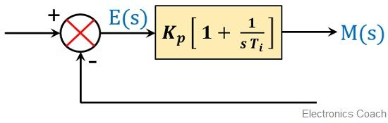

### *Effects of PI Controller*

*To understand the effect of PI controller, consider the PI controller with unity negative feedback given below:*

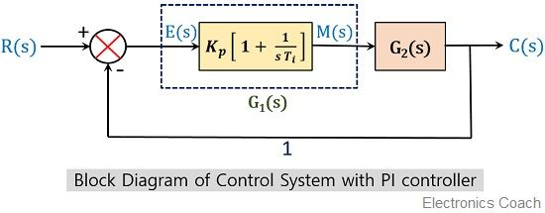

*Suppose the gain of the controller is given as G1(s) whose value we have recently evaluated as:*

**

*And let the open-loop gain of the system be G2(s), given as*

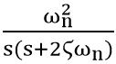

*But the overall loop gain of the system will be*

**

*So, on substituting*

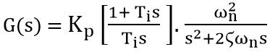

*We know that the gain of the closed-loop system or overall controller is given as:*

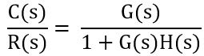

*Since we have already considered the unity feedback system.*

*Therefore,* ***H(s) = 1***

*Thus, the gain will be given as*

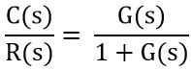

*On substituting the values, we will get,*

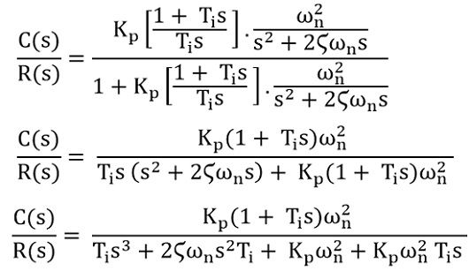

*Taking Ti out from the denominator, we will get*

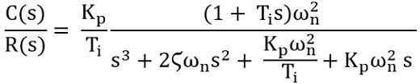

*Since we know*

***Ti = Kp/Ki***

*So substituting Kp/Ti as Ki in above equation we will get*

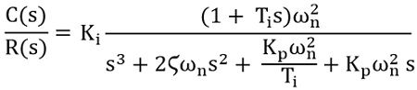

*We have already discussed that PI controllers are designed to decrease the steady-state error. And in order to cause a reduction in steady-state error, the type number must be increased. It is to be noted here that the type number of the controller is defined by the presence of ‘s’ in the transfer function.*

*The above equation clearly indicates that the power of ‘s’ is showing a significant increase in the transfer function. This implies the rise in the type number which resultantly causes a reduction in steady-state error.*

*When the PI controller is not present in the* [*control system*](https://electronicscoach.com/control-system.html) *[31] then there will be absence of ‘s’ in the numerator which will cause the absence of zeros in the transfer function.*

*So, we can say by introducing PI controllers in a control system, the steady-state error of the system gets extremely reduced without affecting the stability of the system.*

*In this project we are using a PI controller to control all the blocks we are using in the simulation process.We also observe some oscillation and overshoot in response to the output of the system. We are using pulse width modulation (PWM) in a standard bidirectional DC/DC converter for generating the triggering pulses of the switches.*

***4.3 Transformation of abc to dq frame***

*The abc to dq transform also known as Park Transform converts the time-domain components of a three-phase system in an abc reference frame to direct, quadrature, and zero components in a rotating reference frame. The block can preserve the active and reactive powers with the powers of the system in the abc reference frame by implementing an invariant version of the park transform. For a balanced system, the zero component is equal to zero [32].*

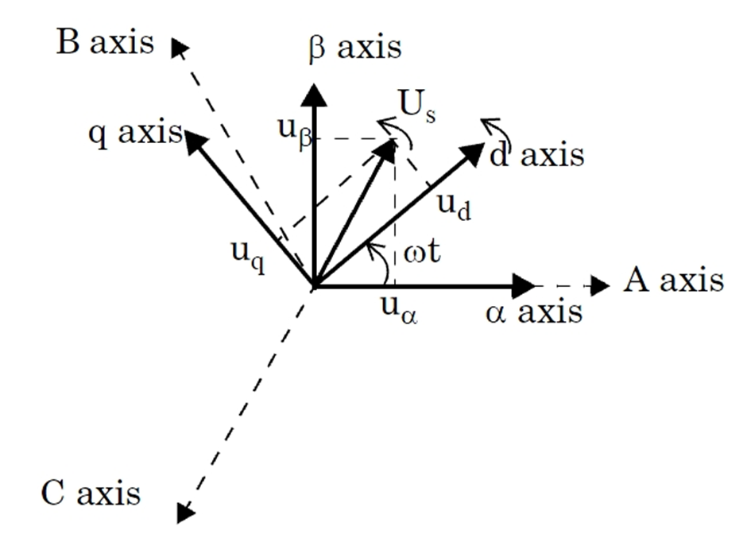

***Fig [transformation from abc to dq]***

***4.3.1 Why we need to transform abc to dq frame***

*If we have a three phase system we have three different phasors, it can be like voltage, it can be like current or it could be like any other phase system.*

*Convenient of transforming abc into dq frame is that we don’t have to deal with three components anymore and in most cases we can actually express those two coordinates as real and imaginary components.*

*The method to transform is that first we go from an abc to alpha-beta frame, let’s say there is a coordinate frame and we call this thing the alpha- beta frame. We could easily decompose all three vectors in (alpha-beta) frames.*

* *Further there is a problem in a three-phase system, let’s say we have an induction machine, the flux rotates which means the machine rotates, it is obvious that the rotation of the machine is linked to the rotation of the flux. When it comes to control if you have a rotating flux the challenge is now that your control will become much more complicated because from a control standpoint, your signal is changing in time or your control variable is changing in time so what we do is we use what is called a dq frame. So the dq frame is basically one step further from the alpha-beta frame.*

# *ABC to DQ*

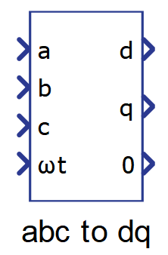

## 

## ***Description***

*The ABC to DQ0 transformation, which is a cascaded mix of Clarke's and Park's transformations, is performed by this component. The three-phase quantities are projected directly onto a synchronously rotating frame using this transformation. This component has the same three modes and two alignment modes as the ABC to transformation and the to dq transformation. For more information, see ABC to and DQ.*

*The component itself is composite, consisting of ABC to and DQ as seen in the diagram below.*

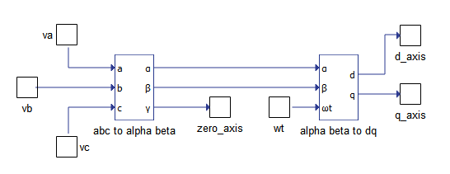

*Figure below illustrates the transformation of a three-phase system to DQ0 frame.*

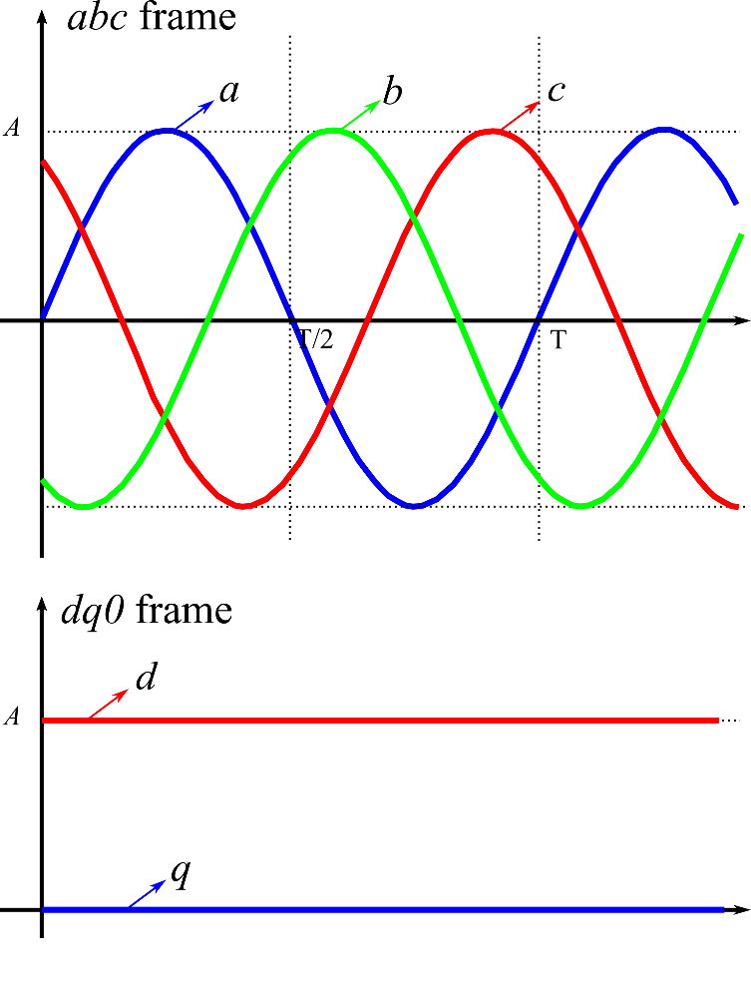

***Chapter 5***

***Simulation and Results***

***5.1 Simulation***

*The proposed V2G system simulation model is established in MATLAB/Simulink. Fig5.1.1 shows the respective model. In this we have taken a 3-phase voltage source having phase to phase voltage of 415V and frequency 50Hz.*

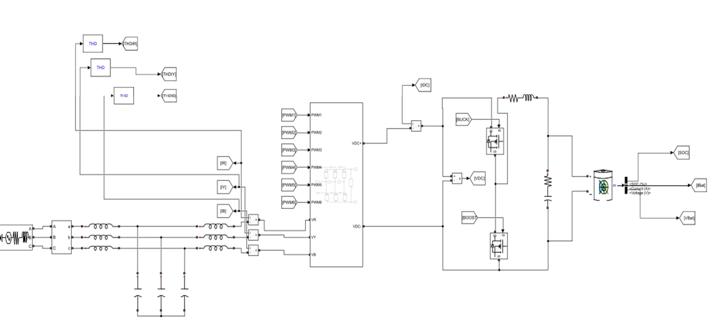

***Fig 5.1.1 Block Diagram of proposed model***

*We are using a bidirectional AC/DC converter which is shown in the figure 5.1.2. For this we have used IGBT whose gate terminal is connected by PWM generators. Further this bidirectional AC/DC converter is connected to the RC branch which is finally connected to the battery whose nominal voltage is 360V and rated capacity is 300V having initial state of charge =50%.*

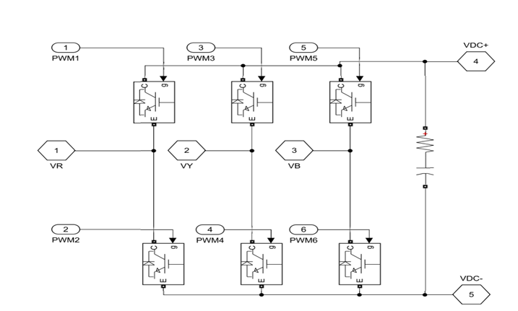

***Fig;5.1.2 Subsystem [bidirectional AC/DC converter]***

*Fig 5.1.3 shows the control scheme mentioned in section 5. The control strategy is categorized into three sub parts. The first part is the inverter controller, the next one is the dc bus voltage controller and the rearmost is the battery current controller.*

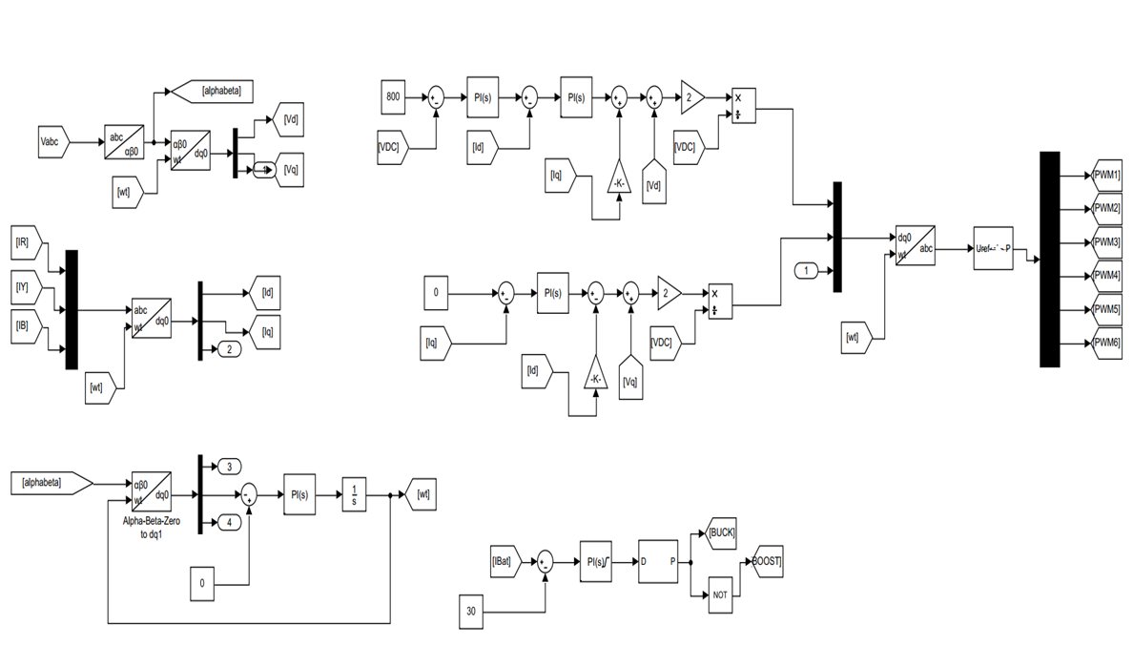

***Fig 5.1.3 [ control blocks of proposed system configuration]***

*In the inverter controller the grid voltage Vabc is transformed to Vd and Vq similarly grid current Ir/Iy/Ib also transformed to the Id and Iq. The transformation is completed with the help of PLL [ phase lock loop] which sets the value of wt. In the DC bus voltage controller, we have taken the reference voltage of 800V by checking the results again and again with other constraints. The voltage signal is then sent to the PI control in order to reduce the steady state error without disturbing the stability of the system. Lastly, we established the battery current controller where we have taken a constant of 30V. We connect it with the PI controller. We are also using a DC-DC PWM generator whose switching frequency is 10000 Hz. The output of the PWM generator is given to the gate terminal of the MOSFET which is working as a DC-DC bidirectional converter in this model.*

***5.2 Results***

***5.2.1 Vehicle to grid mode [ battery discharging]***

*Fig 5.2.1.1 shows the simulation result when the battery is discharged. In this case we have given a constant of 30A to perform the described working. All the results and their graphs are shown ahead.*

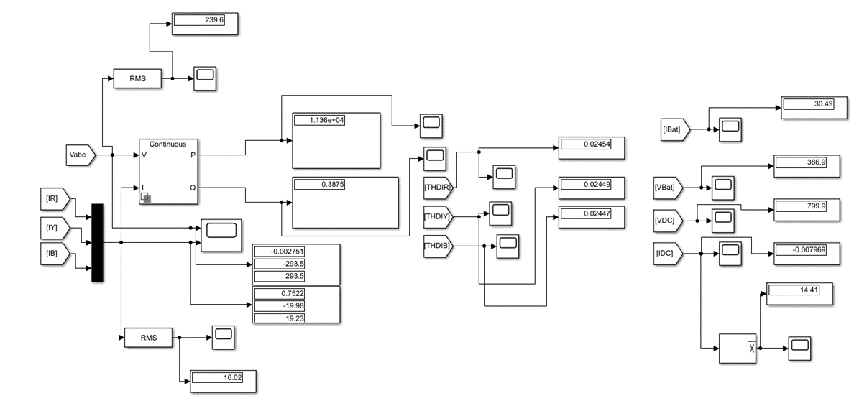

***Fig 5.2.1.1 Simulation result of battery discharging***

*Fig 5.2.1.2(i) and Fig 5.2.1.2(ii) show the simulation result of grid voltage and grid current respectively. In this graph we can observe that both the voltage and current are in the same phase which means we are injecting the power into the grid*

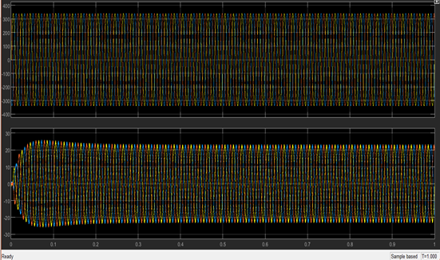 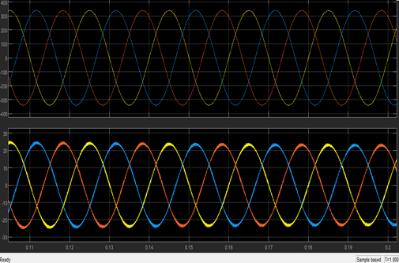

***Fig 5.2.1.2(i) Fig5.2.1.2(ii)***

*Fig5.2.1.2(iii) and Fig 5.2.1.2(iv) show the rms value of voltage and current respectively. The value of rms voltage is 239.6V, it attains the steady state in approximately 0.3 seconds. On the other hand, the value of rms current is 16.02A which also has taken 0.3 seconds to reach the steady state.*

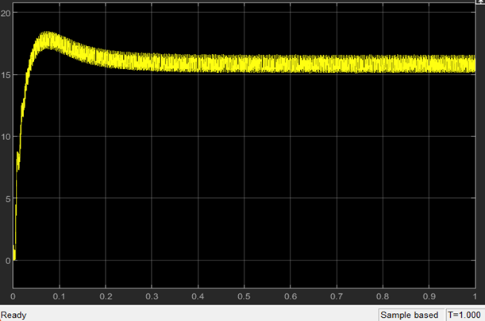

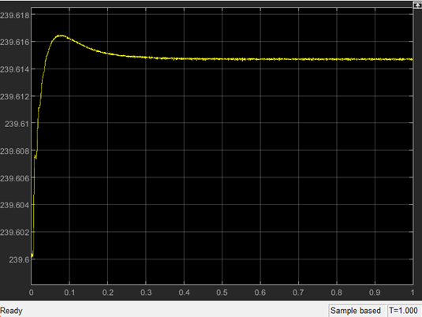

*Fig5.2.1.2(iii) [RMS Vabc] Fig5.2.1.2(iv) [ RMS Iabc]*

*Fig 5.2.1.3 shows the simulation result of battery current. Initially battery current is about 56A. it takes its peak in about 0.002 seconds; the peak current is almost equal to 66A. After 0.4 seconds the battery current settles to 30A.*

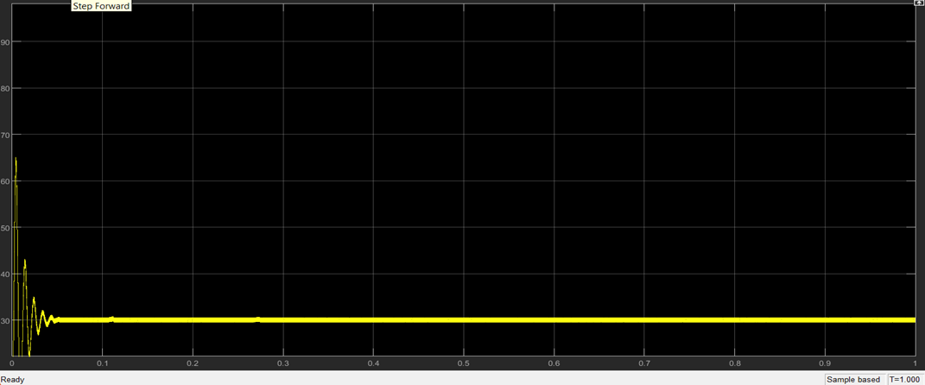

***Fig5.2.1.3 Ibat[ battery current]***

*Fig5.2.1.4 shows the simulation results of the waveform of battery voltage. Initially the voltage of battery is about 387.5V. After over 0.6 seconds it takes its steady state which is approximately equal to 387V*

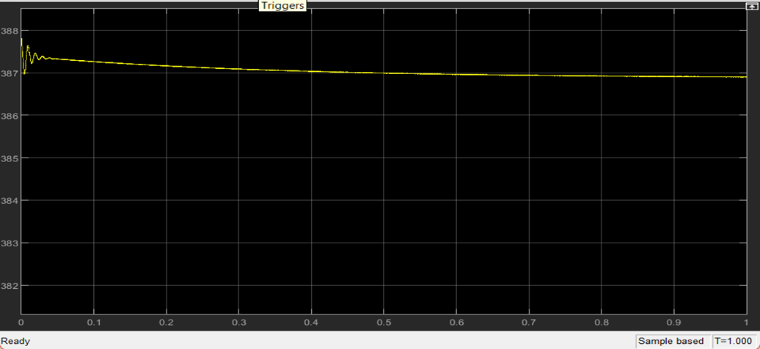

***Fig5.2.1.4 Vbat[ battery voltage ]***

*Fig 5.2.1.5 shows the simulation result of bidirectional AC/DC converter’s output waveform. The output reference voltage is 800V. After about 0.4 seconds the output voltage settles to 800V, which is its steady state. Maximum overshoot of Vdc is about 36V and the peak time is about 0.035 seconds. From the graph we can observe that our settling time came very soon; this is due to the PI controller we have used in our model.*

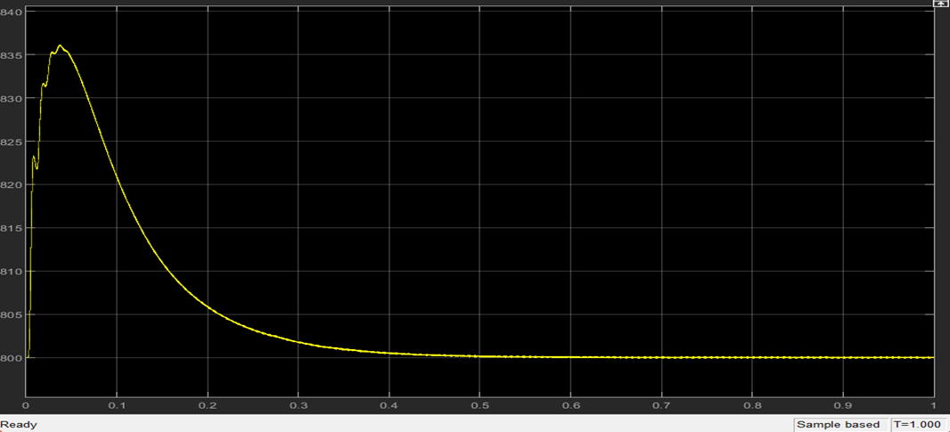

***Fig5.6.1.5Vdc [ DC voltage]***

*Fig 5.2.1.6(i) shows the simulation result of Idc. In the result it is observed that it attains its peak value of about 35A at time approximately equals to 0.016 seconds. The graph reaches its steady state at around 0.045 seconds which is equal to our reference that is 30A.*

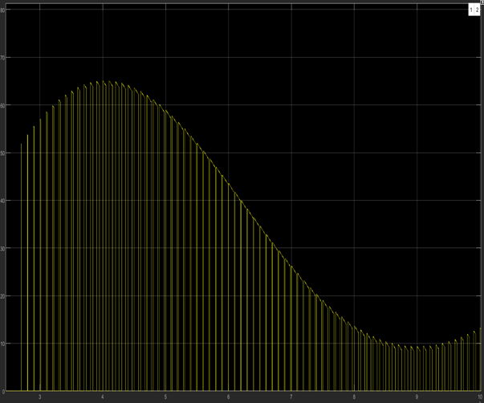

***Fig 5.2.1.6(i) [detailed view of Idc]***

*Fig 5.2.1.6(ii) shows the average value of Idc which is equal to 14.4V. It has seen that it attains its steady state after time around 0.2 seconds. This advantage of early steady state is due to the PI controller we have used throughout our model.*

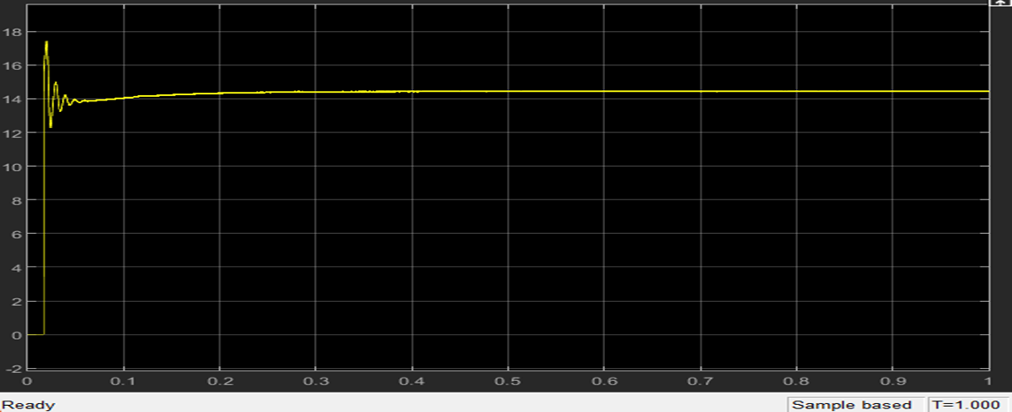

***Fig 5.2.1.6(ii) [ Average Idc]***

*Fig 5.2.1.7[(i), (ii) and (iii)] shows the simulation result of THDs of phase current Ir, Iy and Ib respectively. The values of Ir, Iy and Ib are 0.0245, 0.02449 and 0.02449 respectively which is equal to around 2.4% which lies within the range of IEEE guidelines.*

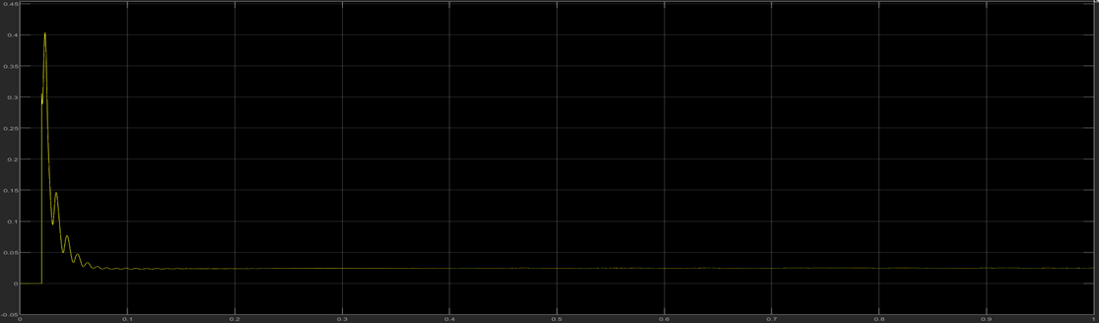

***Fig5.2.1.7(i)[THD of phase current Ir]***

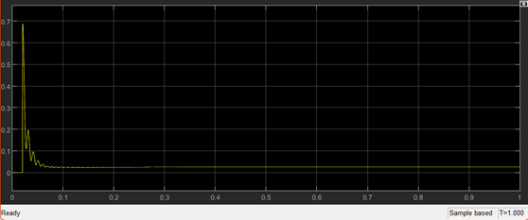 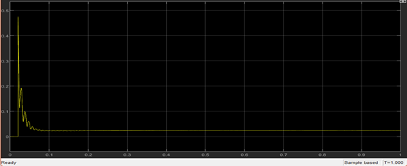

***Fig5.2.1.7(ii)[THD of phase current Iy] Fig5.2.1.7(iii)[THD of phase current Ib]***

*Fig 5.2.1.8[(i)and (ii)] shows the simulation result of Active power and Reactive power of the V2G model respectively. The active power holds the value of 1.136*10^4 whereas reactive power is 0.3875. As reactive power lies within the proposed range of IEEE, we can use it in the further V2G projects.*

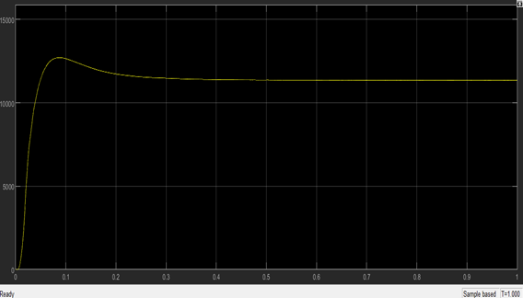 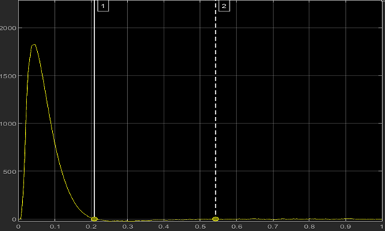

***Fig 5.2.1.8(i) [Active Power P]******fig 5.2.1.8(ii) [Reactive Power Q]***

***5.2.2 Grid to Vehicle [ charging of battery]***

*In Grid to vehicle mode, we charge our battery using bidirectional AC/DC and DC/DC converter. Fig 5.2.2.1 shows the overall simulation result when the battery is getting charged. We can observe the desired result by noting the values shown in the display block. Section ahead shows particular results of grid to vehicle mode.*

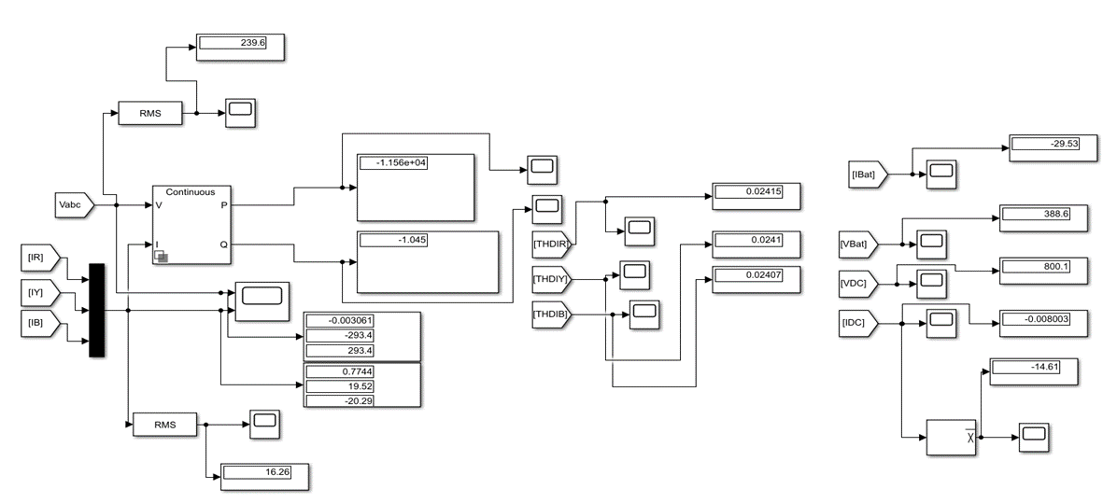

***Fig 5.2.2.1 Simulation result of battery charging***

*Fig 5.2.2.2 shows the simulation result of grid voltage and grid current respectively. In this graph we can observe that both the voltage and current are out of phase which means we are taking power from the grid to charge the battery. By observing this graph, we can define the operation of the grid to vehicle mode.*

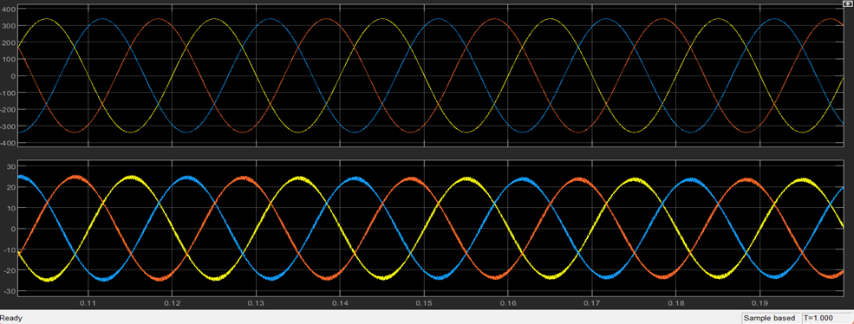

***Fig 5.2.2.2[grid voltage and grid current]***

*Fig 5.2.2.3(i) and Fig 5.2.2.3(ii) are the simulation result of the rms value of voltage and current respectively. From the graph we can observe that RMS voltage is equal to around 239.586V which is attained in approximately 0.4 seconds. On the other hand, the RMS current of the grid is around 15.4A, this steady state is attained in more or less in 0.3 seconds.*

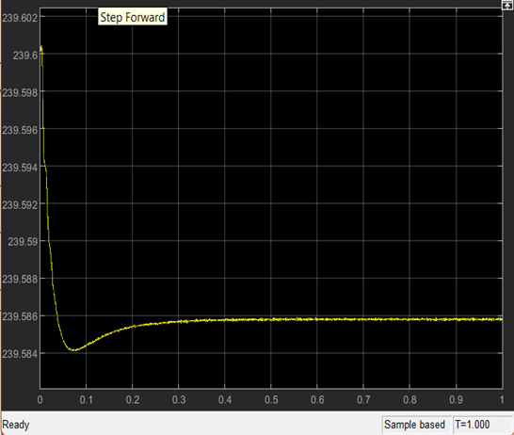 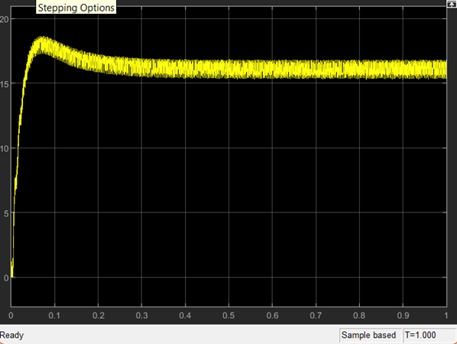

***Fig 5.2.2.3(i)[RMS Vabc] Fig 5.2.2.3(ii)[RMS Iabc]***

*Fig 5.2.2.4 shows the simulation result of battery current. The negative value refers to the charging of the battery. According to the resultant graph the current reaches to the peak of around -56A in about 0.006 seconds. It attains the steady state value of -30A in about 0.03 seconds.*

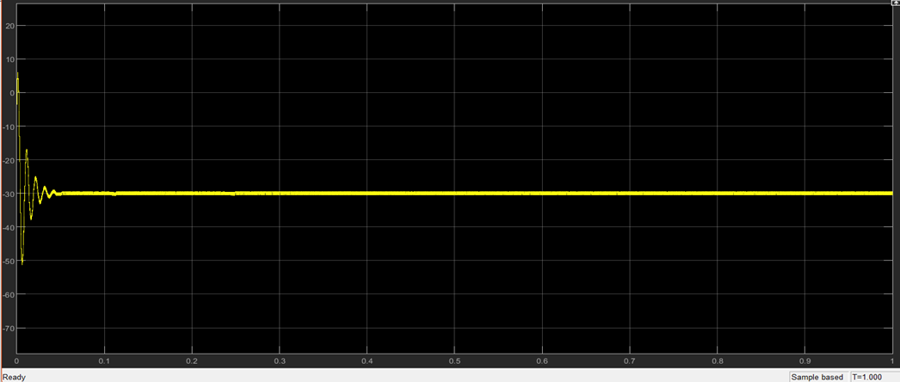

***Fig5.2.2.4[ Ibat ]***

*Fig 6.2.2.5 shows the simulation result of the waveform of the battery voltage. From the resultant graph we can find that after 0.6 seconds the battery voltage attains the steady state of 388.6V.*

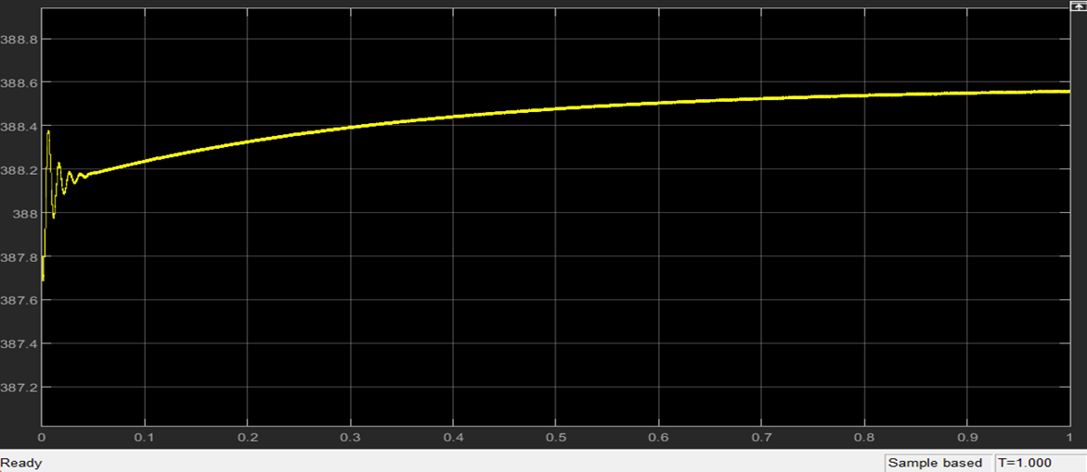

***Fig 5.2.2.5[Vbat]***

*Fig 5.2.2.6 shows the simulation result of bidirectional AC/DC converter’s output waveform. The output reference voltage is 800V. After about 0.45 seconds the output voltage settles to around 800.1V that is its steady state. Maximum overshoot of Vdc is about -36V and the peak time is about 0.035 seconds.*

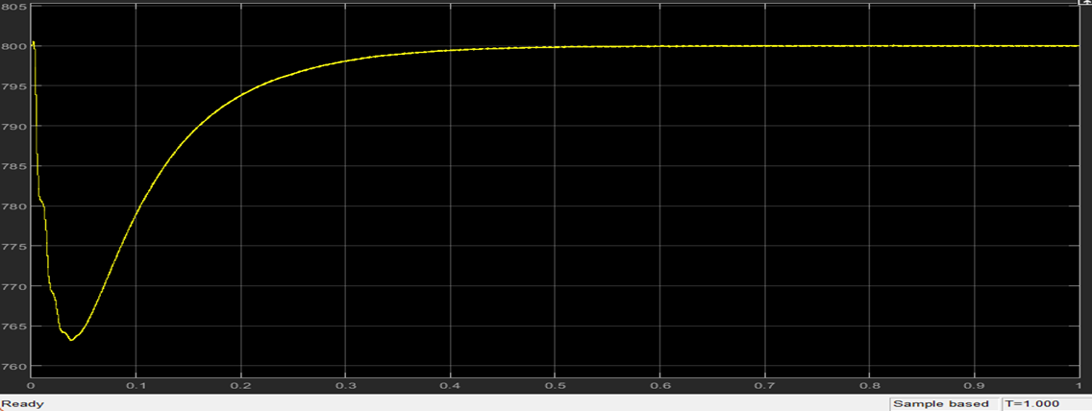

***Fig 5.2.2.6[Vdc]***

*Fig 5.2.2.7(i) shows the simulation result of Idc. In the result it has shown that it obtained its peak value of about -35A at time approximately equals to 0.016 seconds. The graph reaches its steady state at around 0.045 seconds which is equal to our reference that is -30A.*

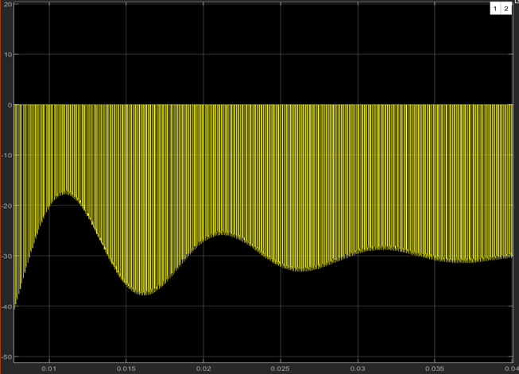

***Fig 5.2.2.7(ii)[ Detailed view of Idc]***

*Fig 5.2.2.7(ii) shows the average value of Idc which is equal to -14.4V. It has seen that it attains its steady state after time around 0.2 seconds. The negative value refers to charging of the vehicle battery. With the PI controller steady state came earlier.*

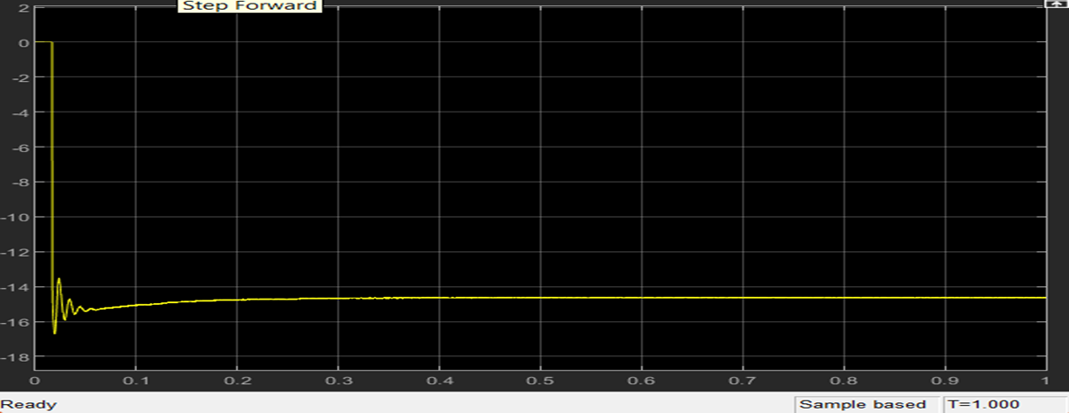

***Fig 5.2.2.7(iii)[Average of Idc]***

*Fig 5.2.2.8[(i),(ii) and (iii)] shows the simulation result of THDs of phase current Ir, Iy and Ib respectively. The value of Ir, Iy and Ib are 0.02415, 0.0241 and 0.02407 respectively which is equal to around 2.4% and according to IEEE the THD should not be greater than 5%, as the resultant THD lies within the range we can consider these results*

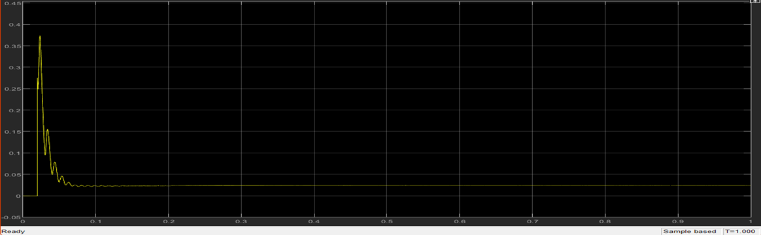

***Fig5.2.2.8(i)[THD of Ir]***

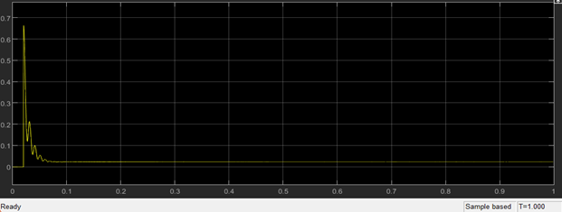 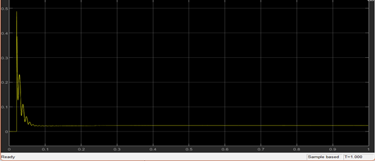

***Fig 5.2.2.8(ii)[THD of Iy] Fig 5.2.2.8(iii)[THD of Ib]***

*Fig 5.2.2.9[(i)and (ii)] shows the simulation result of Active power and Reactive power of the grid to vehicle mode. The active power controls it’s steady state value of -1.156*10^4 whereas reactive power is -1.045. As the resultant power is negative which means the power is taken from the grid to charge the battery, also the reactive power falls within the range of the guidelines set by IEEE.*

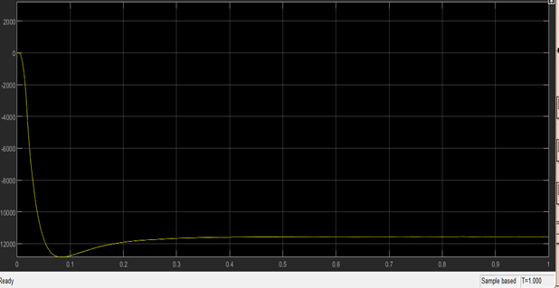

***Fig5.2.2.9(i)[Active Power]***

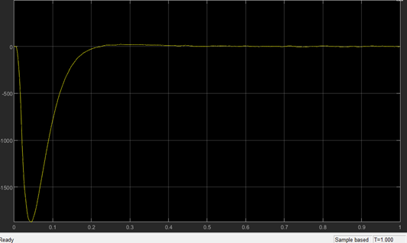

***Fig 5.2.2.9(ii)[Reactive Power]***

***6. Conclusion***

*In this paper the bidirectional AC/DC and DC/DC converter was designed and simulated for electric vehicle charging stations. The result for vehicle to grid and grid to vehicle was successfully achieved. In this project the PI controller of voltage and current is also designed in order to get a quick steady state. It also produces less variation in output voltage. Also, the three phase AC/DC converter’s exact model was transformed to the synchronous d-q frame. Eventually the model was completed in MATLAB/Simulink. The result of experiment and simulation show the converter performs efficiently for both vehicle to grid and grid to vehicle application having low harmonics, low voltage ripple and low current THD. The output also verifies the active and reactive power in both the operation, with active power coming too high we are getting reactive power very low which is efficient to the work. This performance of the proposed bidirectional converter using proportional integral (PI) controller for the proposed operation that is vehicle to grid and grid to vehicle charging was then extensively investigated under the simulation study.*

**REFERENCES**

[1] A. K. Karmaker, S. Roy and M. R. Ahmed, "Analysis of the Impact of Electric Vehicle

Charging Station on Power Quality Issues," 2019 International Conference on Electrical,

Computer and Communication Engineering (ECCE), Cox's Bazar, Bangladesh, pp. 1-6.

2019.

[2] A K Karmaker, MR Ahmed, MA Hossain, and MM Sikder. “Feasibility assessment &

design of hybrid renewable energy based electric vehicle charging station in Bangladesh.”

Sustainable Cities and Society 39: 189-202. 2018.

[3] J. Wi, H. Kim, J. Yoo, H. Son, H. Kim and B. Kim, "Energy consumption of parallel type

hybrid electric vehicle with continuously variable transmission using electric oil pump,"

2018 Thirteenth International Conference on Ecological Vehicles and Renewable Energies

(EVER), Monte-Carlo, pp. 1-7. 2018.

[4] S. Habib, M. M. Khan, F. Abbas, L. Sang, M. U. Shahid, and H. Tang, “A comprehensive study of implemented international standards, technical challenges, impacts and prospects for electric vehicles,” *IEEE Access*, vol. 6, pp. 13866–13890, 2018. View at: [Publisher Site](https://doi.org/10.1109/access.2018.2812303) | [Google Scholar](https://scholar.google.com/scholar_lookup?title=A%20comprehensive%20study%20of%20implemented%20international%20standards,%20technical%20challenges,%20impacts%20and%20prospects%20for%20electric%20vehicles&author=S.%20Habib&author=M.%20M.%20Khan&author=F.%20Abbas&author=L.%20Sang&author=M.%20U.%20Shahid&author=&author=H.%20Tang&publication_year=2018)

[5] S. Esther, S. K. Singh, A. K. Goswami et al., “Recent challenges in vehicle to grid integrated renewable energy system: a review,” in *Proceedings of the 2018 Second International Conference on Intelligent Computing and Control Systems (ICICCS)*, pp. 427–435, Madurai, India, 2018. View at: [Google Scholar](https://scholar.google.com/scholar_lookup?title=Recent%20challenges%20in%20vehicle%20to%20grid%20integrated%20renewable%20energy%20system:%20a%20review&author=S.%20Esther&author=S.%20K.%20Singh&author=A.%20K.%20Goswami%20et%20al.)

[6] P. K. Joseph, E. Devaraj, and A. Gopal, “Overview of wireless charging and vehicle-to-grid integration of electric vehicles using renewable energy for sustainable transportation,” *IET Power Electronics*, vol. 12, no. 4, pp. 627–638, 2019. View at: [Publisher Site](https://doi.org/10.1049/iet-pel.2018.5127) | [Google Scholar](https://scholar.google.com/scholar_lookup?title=Overview%20of%20wireless%20charging%20and%20vehicle-to-grid%20integration%20of%20electric%20vehicles%20using%20renewable%20energy%20for%20sustainable%20transportation&author=P.%20K.%20Joseph&author=E.%20Devaraj&author=&author=A.%20Gopal&publication_year=2019)

[7] M. A. Masrur, A. G. Skowronska, J. Hancock et al., “Military-based vehicle-to-grid and vehicle-to-vehicle microgrid-system Architecture and implementation,” *IEEE Transactions on Transportation Electrification*, vol. 4, no. 1, pp. 157–171, 2018.View at: [Publisher Site](https://doi.org/10.1109/tte.2017.2779268) | [Google Scholar](https://scholar.google.com/scholar_lookup?title=Military-based%20vehicle-to-grid%20and%20vehicle-to-vehicle%20microgrid-system%20Architecture%20and%20implementation&author=M.%20A.%20Masrur&author=A.%20G.%20Skowronska&author=J.%20Hancock%20et%20al.&publication_year=2018)

[8] B. Sah, P. Kumar, R. Rayudu, S. K. Bose, and K. P. Inala, “Impact of sampling in the operation of vehicle to grid and its mitigation,” *IEEE Transactions on Industrial Informatics*, vol. 15, no. 7, pp. 3923–3933, 2019.

View at: [Publisher Site](https://doi.org/10.1109/tii.2018.2886633) | [Google Scholar](https://scholar.google.com/scholar_lookup?title=Impact%20of%20sampling%20in%20the%20operation%20of%20vehicle%20to%20grid%20and%20its%20mitigation&author=B.%20Sah&author=P.%20Kumar&author=R.%20Rayudu&author=S.%20K.%20Bose&author=&author=K.%20P.%20Inala&publication_year=2019)

[9] T. Chen, X.-P. Zhang, J. Wang et al., “A review on electric vehicle charging infrastructure development in the UK,” *Journal of Modern Power Systems and Clean Energy*, vol. 8, no. 2, pp. 193–205, 2020. View at: [Publisher Site](https://doi.org/10.35833/mpce.2018.000374) | [Google Scholar](https://scholar.google.com/scholar_lookup?title=A%20review%20on%20electric%20vehicle%20charging%20infrastructure%20development%20in%20the%20UK&author=T.%20Chen&author=X.-P.%20Zhang&author=J.%20Wang%20et%20al.&publication_year=2020)

[10] S. I. Vagropoulos, G. A. Balaskas, and A. G. Bakirtzis, “An investigation of plug-in electric vehicle charging impact on power systems scheduling and energy costs,” *IEEE Transactions on Power Systems*, vol. 32, no. 3, pp. 1902–1912, 2017. View at: [Publisher Site](https://doi.org/10.1109/tpwrs.2016.2609933) | [Google Scholar](https://scholar.google.com/scholar_lookup?title=An%20investigation%20of%20plug-in%20electric%20vehicle%20charging%20impact%20on%20power%20systems%20scheduling%20and%20energy%20costs&author=S.%20I.%20Vagropoulos&author=G.%20A.%20Balaskas&author=&author=A.%20G.%20Bakirtzis&publication_year=2017)

[11] A. Sridhar and A. R. Prabu, *Bidirectional AC-DC Converter for Vehicle-To-Grid (V2G) Applications*, Marquette University, Milwaukee, WI, USA, 2015.

[12] S. Liu, D. Xin, and L. Yang, “A novel single-phase bidirectional electric-drive-reconstructed onboard converter for electric vehicles,” *IEEE Access*, vol. 8, pp. 44739–44747, 2020. View at: [Publisher Site](https://doi.org/10.1109/access.2020.2970201) | [Google Scholar](https://scholar.google.com/scholar_lookup?title=A%20novel%20single-phase%20bidirectional%20electric-drive-reconstructed%20onboard%20converter%20for%20electric%20vehicles&author=S.%20Liu&author=D.%20Xin&author=&author=L.%20Yang&publication_year=2020)

[13] J. Zhang, H. Yan, N. Ding et al., “Electric vehicle charging network development characteristics and policy suggestions,” in *Proceedings of the 2018 International Symposium on Computer, Consumer and Control (IS3C)*, pp. 469–472, Taichung, China, 2018. View at: [Google Scholar](https://scholar.google.com/scholar_lookup?title=Electric%20vehicle%20charging%20network%20development%20characteristics%20and%20policy%20suggestions&author=J.%20Zhang&author=H.%20Yan&author=N.%20Ding%20et%20al.)

[14] B. Koushki, P. Jain, and A. Bakhshai, “Topology and controller of an isolated bi-directional AC-DC converter for electric vehicle,” in *Proceedings of the 2016 IEEE Energy Conversion Congress and Exposition (ECCE)*, pp. 1–8, Milwaukee, WI, USA, 2016. View at: [Google Scholar](https://scholar.google.com/scholar_lookup?title=Topology%20and%20controller%20of%20an%20isolated%20bi-directional%20AC-DC%20converter%20for%20electric%20vehicle&author=B.%20Koushki&author=P.%20Jain&author=&author=A.%20Bakhshai)

[15] K. V. Sing, H. O. Bansal, and D. Singh, “A comprehensive review on hybrid electric vehicles: architectures and components,” *Journal of Modern Transportation*, vol. 27, no. 2, pp. 77–107, 2019.

View at: [Google Scholar](https://scholar.google.com/scholar_lookup?title=A%20comprehensive%20review%20on%20hybrid%20electric%20vehicles:%20architectures%20and%20components&author=K.%20V.%20Sing&author=H.%20O.%20Bansal&author=&author=D.%20Singh&publication_year=2019)

[16] P. Yang, T. Peng, H. Wang et al., “A single-phase current-source bidirectional converter for V2G application,” in *Proceedings of the 2017 IEEE 3rd International Future Energy Electronics Conference and ECCE Asia (IFEEC 2017-ECCE Asia)*, pp. 704–709, Kaohsiung, Taiwan, 2017.View at: [Google Scholar](https://scholar.google.com/scholar_lookup?title=A%20single-phase%20current-source%20bidirectional%20converter%20for%20V2G%20application&author=P.%20Yang&author=T.%20Peng&author=H.%20Wang%20et%20al.)

[17] A. K. Singh and M. K. Pathak, “Single-phase bidirectional ac/dc converter for plug-in electric vehicles with reduced conduction losses,” *IET Power Electronics*, vol. 11, no. 1, pp. 140–148, 2018.

View at: [Publisher Site](https://doi.org/10.1049/iet-pel.2016.0899) | [Google Scholar](https://scholar.google.com/scholar_lookup?title=Single-phase%20bidirectional%20ac/dc%20converter%20for%20plug-in%20electric%20vehicles%20with%20reduced%20conduction%20losses&author=A.%20K.%20Singh%20&author=M.%20K.%20Pathak&publication_year=2018)

[18] B. Singh and R. Kushwaha, “A PFC based EV battery charger using a bridgeless isolated SEPIC converter,” *IEEE Transactions on Industry Applications*, vol. 56, no. 1, pp. 477–487, 2020.

View at: [Publisher Site](https://doi.org/10.1109/tia.2019.2951510) | [Google Scholar](https://scholar.google.com/scholar_lookup?title=A%20PFC%20based%20EV%20battery%20charger%20using%20a%20bridgeless%20isolated%20SEPIC%20converter&author=B.%20Singh%20&author=R.%20Kushwaha&publication_year=2020)

[19] B. Singh and R. Kushwaha, “A PFC based EV battery charger using a bridgeless isolated SEPIC converter,” IEEE Transactions on Industry Applications, vol. 56, no. 1, pp. 477–487, 2020.

View at: Publisher Site | Google Scholar

[20] T.-L. Nguyen and H.-H. Lee, “An enhanced control strategy for AC-DC matrix converters under unbalanced grid voltage,” *IEEE Transactions on Industrial Electronics*, vol. 67, no. 3, pp. 1718–1727, 2020.View at: [Publisher Site](https://doi.org/10.1109/tie.2019.2907452) | [Google Scholar](https://scholar.google.com/scholar_lookup?title=An%20enhanced%20control%20strategy%20for%20AC-DC%20matrix%20converters%20under%20unbalanced%20grid%20voltage&author=T.-L.%20Nguyen%20&author=H.-H.%20Lee&publication_year=2020)

[21] D. Mishra, B. Singh, and B. K. Panigrahi, “Adaptive current control for a Bi-directional interleaved EV charger with disturbance rejection,” in *Proceedings of the 2020 IEEE International Conference on Power Electronics*, pp. 1–6, Smart Grid and Renewable Energy (PESGRE2020), Cochin, India, 2020.

View at: [Google Scholar](https://scholar.google.com/scholar_lookup?title=Adaptive%20current%20control%20for%20a%20Bi-directional%20interleaved%20EV%20charger%20with%20disturbance%20rejection&author=D.%20Mishra&author=B.%20Singh&author=&author=B.%20K.%20Panigrahi)[22] J. Zhao and Q. Jiang, “Research on a new control strategy for three-phase current-source PWM rectifier,” in *Proceedings of the 2017 Eighth International Conference on Intelligent Control and Information Processing (ICICIP)*, pp. 157–161, Hangzhou, China, 2017. View at: [Google Scholar](https://scholar.google.com/scholar_lookup?title=Research%20on%20a%20new%20control%20strategy%20for%20three-phase%20current-source%20PWM%20rectifier&author=J.%20Zhao%20&author=Q.%20Jiang)

[23] O. Noureldeen, I. Hamdan, and B. Hassanin, “Design of advanced artificial intelligence protection technique based on low voltage ride-through grid code for large-scale wind farm generators: a case study in Egypt,” *SN Applied Sciences*, vol. 1, no. 6, pp. 1–19, 2019.View at: [Publisher Site](https://doi.org/10.1007/s42452-019-0538-9) | [Google Scholar](https://scholar.google.com/scholar_lookup?title=Design%20of%20advanced%20artificial%20intelligence%20protection%20technique%20based%20on%20low%20voltage%20ride-through%20grid%20code%20for%20large-scale%20wind%20farm%20generators:%20a%20case%20study%20in%20Egypt&author=O.%20Noureldeen&author=I.%20Hamdan&author=&author=B.%20Hassanin&publication_year=2019)

[24] O. Noureldeen and I. Hamdan, “Design of robust intelligent protection technique for large-scale grid-connected wind farm,” *Protection and Control of Modern Power Systems*, vol. 3, no. 1, pp. 1–13, 2018.

View at: [Publisher Site](https://doi.org/10.1186/s41601-018-0090-4) | [Google Scholar](https://scholar.google.com/scholar_lookup?title=Design%20of%20robust%20intelligent%20protection%20technique%20for%20large-scale%20grid-connected%20wind%20farm&author=O.%20Noureldeen%20&author=I.%20Hamdan&publication_year=2018)

[25] K. Qian, G. Gao, and Z. Sheng, “A maximum current control method for three-phase PWM rectifier for the ITER in-vessel vertical stability coil power supply,” *IEEE Transactions on Plasma Science*, vol. 46, no. 5, pp. 1689–1693, 2018. View at: [Publisher Site](https://doi.org/10.1109/tps.2017.2787579) | [Google Scholar](https://scholar.google.com/scholar_lookup?title=A%20maximum%20current%20control%20method%20for%20three-phase%20PWM%20rectifier%20for%20the%20ITER%20in-vessel%20vertical%20stability%20coil%20power%20supply&author=K.%20Qian&author=G.%20Gao&author=&author=Z.%20Sheng&publication_year=2018)

[26] W. Li, X. Ruan, D. Pan, and X. Wang, “Full-feedforward schemes of grid voltages for a three-phase $LCL$-Type grid-connected inverter,” *IEEE Transactions on Industrial Electronics*, vol. 60, no. 6, pp. 2237–2250, 2013.View at: [Publisher Site](https://doi.org/10.1109/tie.2012.2193864) | [Google Scholar](https://scholar.google.com/scholar_lookup?title=Full-feedforward%20schemes%20of%20grid%20voltages%20for%20a%20three-phase%20$LCL$-Type%20grid-connected%20inverter&author=W.%20Li&author=X.%20Ruan&author=D.%20Pan&author=&author=X.%20Wang&publication_year=2013)

[27] Wikimedia Foundation. (2022, June 11). Hybrid Electric Vehicle. Wikipedia. Retrieved June 15, 2022, from https://en.m.wikipedia.org/wiki/Hybrid_electric_vehicle

[28] Wikimedia Foundation. (2022, June 7). Plug-in hybrid. Wikipedia. Retrieved June 15, 2022, from https://en.m.wikipedia.org/wiki/Plug-in_hybrid#:~:text=A%20plug%2Din%20hybrid%20electric,internal%20combustion%20engine%2Dpowered%20generator

[29] Wikimedia Foundation. (2022, June 4). Mild hybrid. Wikipedia. Retrieved June 15, 2022, from https://en.m.wikipedia.org/wiki/Mild_hybrid

[30] What *are controllers? types of controllers*. Electronics Coach. (2020, January 20). Retrieved June 15, 2022, from https://electronicscoach.com/types-of-controllers.html

[31] *What is control system? definition, need, features and types and block diagram of Control System*. Electronics Coach. (2019, November 28). Retrieved June 15, 2022, from https://electronicscoach.com/control-system.html

[32] *ABC to DQ0, DQ0 to ABC*. Perform transformation from three-phase (abc) signal to dq0 rotating reference frame or the inverse - Simulink. (n.d.). Retrieved June 15, 2022, from https://www.mathworks.com/help/physmod/sps/powersys/ref/abctodq0dq0toabc.html#:~:text=The%20abc%20to%20dq0%20block,the%20input%20wt%2C%20in%20rad.

Wikimedia Foundation. (2022, June 4). *Battery Electric Vehicle*. Wikipedia. Retrieved June 15, 2022, from https://en.m.wikipedia.org/wiki/Battery_electric_vehicle

*RF Wireless World*. Difference between Conductive charging vs Inductive charging. (n.d.). Retrieved June 15, 2022, from https://www.rfwireless-world.com/Terminology/Difference-between-Conductive-charging-and-Inductive-charging.html

Editor. (2020, July 3). *Editor, Chary Publications*. Electrical India. Retrieved June 15, 2022, from https://www.electricalindia.in/a-review-of-battery-charger-topologies-and-infrastructure-for-plug-in-electric-and-hybrid-vehicles-part-1/#:~:text=Charger%20systems%20are%20categorized%20into,injection%20back%20to%20the%20grid.

Moloughney, T. (2022, April 20). *What are the different levels of electric vehicle charging?* Forbes. Retrieved June 15, 2022, from https://www.forbes.com/wheels/advice/ev-charging-levels/?amp

Google. (n.d.). Google search. Retrieved June 15, 2022, from https://www.google.com/search?q=configuration%2Bof%2Bv2g%2Bsystem&client=ms-android-samsung-ga-rev1&prmd=nisv&source=lnms&tbm=isch&sa=X&ved=2ahUKEwj_wOPA2IX4AhWMZ2wGHUmuCwcQ_AUoAnoECAIQAg&biw=412&bih=776&dpr=2.63#imgrc=kfEpUqHEukGiJM